TABLE OF CONTENTS
UNITED STATES
SECURITIES AND EXCHANGE COMMISSION
WASHINGTON, D.C. 20549
SCHEDULE 14A
Proxy Statement Pursuant to
Section 14(a) of the Securities Exchange Act of 1934
Filed by the Registrant ☑
Filed by a Party other than the Registrant ☐
Check the appropriate box:
☐ |  |  | Preliminary Proxy Statement
☐ |  |  | Confidential, for Use of the Commission Only (as permitted by Rule 14a-6(e)(2))
☑ |  |  | Definitive Proxy Statement
☐ |  |  | Definitive Additional Materials
☐ |  |  | Soliciting Material Pursuant to §240.14a-12
RBC Bearings Incorporated
(Name of Registrant as Specified In Its Charter)
(Name of Person(s) Filing Proxy Statement, if other than the Registrant)
Payment of Filing Fee (Check all boxes that apply):
☑ |  |  | No fee required.
☐ |  |  | Fee paid previously with preliminary materials.
☐ |  |  | Fee computed on table in exhibit required by Item 25(b) per Exchange Act Rules 14a6(i)(1) and 0-11.

TABLE OF CONTENTS


One Tribology Center
Oxford, Connecticut 06478
July 24, 2026
To our stockholders:
You are cordially invited to attend the RBC Bearings Incorporated annual meeting of stockholders to be held at 9:00 a.m., local time, on Thursday, September 3, 2026 in Building B at our offices located at One Tribology Center, 102 Willenbrock Road, Oxford, CT 06478. The attached Notice of Annual Meeting and Proxy Statement describe all items that we currently expect to be acted upon by stockholders at the meeting.
It is important that your shares are represented at the annual meeting, whether or not you plan to attend. To ensure your shares will be represented, please vote your shares as soon as possible.
Fiscal 2026 marked another outstanding year for RBC with record revenues, gross margin, adjusted EBITDA and net income. We also generated a record level of free cash flow, which was used to further reduce our debt and acquire VACCO Industries. This resulted in a 5-year CAGR of 25.2% for net sales, 28.3% for adjusted EBITDA and 19.5% for free cash flow. This more than delivered on RBC’s goal of being a double-digit compounder, and we’re poised to continue this growth in the future.
Your continued support of RBC is greatly appreciated. We look forward to seeing you at the annual meeting.
Sincerely,


Dr. Michael J. Hartnett
Chairman, President and Chief Executive Officer
 |  |  |  |  |  | 2026 Proxy Statement |  |  | 01

TABLE OF CONTENTS

Notice of 2026 Annual
Meeting of Stockholders
 | Date and Time: |  |  | Place:
 | Thursday, September 3, 2026  9:00 a.m. Local Time |  |  | Building B  One Tribology Center  102 Willenbrock Road  Oxford, CT 06478
Purpose
The 2026 annual meeting of stockholders of RBC Bearings Incorporated will be held in Building B at our executive offices at One Tribology Center, 102 Willenbrock Road, Oxford, CT 06478, on Thursday, September 3, 2026, beginning at 9:00 a.m. local time. At the meeting, the holders of the Company’s outstanding common stock will consider and vote on the following matters:
 | Proposal |  |  | Board Recommendation
 | 1.To elect two directors in Class III to serve a term of three years; |  |  | FOR all Director Nominees
 | 2.To ratify the appointment of Ernst & Young LLP as our independent registered public accounting firm for fiscal year 2027; and |  |  | FOR
 | 3.To seek approval, on a non-binding advisory basis, of the compensation of our named executive officers. |  |  | FOR
Stockholders of record at the close of business on July 7, 2026 are entitled to notice of and to vote at the annual meeting and at any postponements or adjournments thereof. The directions to the meeting can be found in Appendix A of the attached proxy statement.
Your Vote is Important
Whether or not you plan to attend the meeting, please vote your shares. You can find voting instructions in the proxy statement or in the materials you received for the meeting. Any person voting by proxy has the power to revoke it, at any time prior to its exercise at the meeting, in accordance with the procedures described in the attached proxy statement.
If You Plan to Attend
Please note that space constraints make it necessary to limit attendance to stockholders and one guest. Admission to the meeting will be on a first-come, first-served basis. Registration will begin at 8:00 a.m., and seating will begin at 8:30 a.m. Each stockholder may be asked to present valid picture identification, such as a driver’s license or passport. Stockholders holding stock in brokerage accounts (i.e., “street name” holders) will also need to bring a copy of a brokerage statement reflecting RBC stock ownership as of the record date. Cellular phones, cameras, recording devices and other electronic devices will not be permitted at the meeting.
By order of the Board of Directors,

Dr. Michael J. Hartnett
Chairman, President and Chief Executive Officer
July 24, 2026
02 |  |  |  |  |  | 2026 Proxy Statement

TABLE OF CONTENTS
Table of Contents

 | Business Highlights |  |  | 4
 | Proposals Submitted for Stockholder Vote |  |  | 8
 | Proposal 1: Election of Directors |  |  | 8
 | Proposal 2: The Ratification of the Appointment of Ernst & Young as the Company’s Independent Registered Public Accounting Firm for 2027 |  |  | 9
 | Proposal 3: Advisory Vote on Executive Compensation |  |  | 10
 | Board of Directors and Corporate Governance |  |  | 11
 | Director Independence |  |  | 11
 | Committees of the Board of Directors |  |  | 12
 | Director Qualifications |  |  | 13
 | Board Leadership Structure |  |  | 15
 | Stockholder Outreach |  |  | 15
 | Director Compensation |  |  | 15
 | Certain Relationships and Related Transactions |  |  | 17
 | Principal Stockholders |  |  | 17
 | Directors and Officers |  |  | 17
 | Outside Investors |  |  | 18
 | Directors and Executive Officers |  |  | 19
 | Compensation Discussion and Analysis |  |  | 24
 | Compensation Philosophy |  |  | 24
 | Stockholder Engagement and Outreach |  |  | 26
 | Compensation Program Components and Pay Outcomes for Fiscal 2026 |  |  | 26
 | Benefits and Perquisites |  |  | 32
 | Executive Compensation Process and Policies |  |  | 33
 | Compensation Peer Group |  |  | 34
 | Compensation Governance Policies |  |  | 34
 | Compensation Committee Report on Executive Compensation |  |  | 35
 | Employment Agreements and Change-in-Control and Severance Arrangements |  |  | 35
 | Compensation Tables |  |  | 38
 | Pay Versus Performance |  |  | 42
 | Equity Incentive Plans |  |  | 48
 | CEO Pay Ratios |  |  | 50
 | Principal Accounting Fees and Services |  |  | 50
 | Audit Committee Report |  |  | 51
 | Stockholder Proposals and Director Nominations |  |  | 51
 | Additional Information About the Annual Meeting |  |  | 52
 | Appendix A: Directions to RBC |  |  | 55
 | Appendix B: Reconciliation of Reported Net Income to Adjusted EBITDA |  |  | 56
 |  |  |  |  |  | 2026 Proxy Statement |  |  | 03

TABLE OF CONTENTS

Proxy Statement for 2026 Annual
Meeting of Stockholders
The Board of Directors (the “Board”) of RBC Bearings Incorporated is soliciting proxies from our stockholders to be used at the annual meeting of stockholders to be held on Thursday, September 3, 2026, beginning at 9:00 a.m., local time, in Building B at our principal executive offices, located at One Tribology Center, 102 Willenbrock Road, Oxford, Connecticut 06478, and at any postponements or adjournments thereof. This proxy statement, a proxy card and the Company’s Annual Report on Form 10-K for fiscal 2026 are being mailed, or made available via the internet as described below, to stockholders on or about July 24, 2026.
Our fiscal years end on the Saturday closest to March 31 each year. Fiscal 2026 ended on March 28, 2026 and fiscal 2027 will end on April 3, 2027. As used in this proxy statement, the terms “we,” “us,” “our,” “RBC” and “the Company” mean RBC Bearings Incorporated and its subsidiaries.
Business Highlights
Who We Are
RBC Bearings is a leading international manufacturer of highly engineered precision bearings, components and essential systems for the industrial, aerospace and defense industries.
 | Founder-Led Growth Company
 | RBC was built through a series of acquisitions led by CEO Dr. Michael J. Hartnett, culminating in 30 transactions over 34 years. The combination of organic and inorganic growth has resulted in double-digit through-cycle revenue growth coupled with healthy margin expansion and free cash flow generation. The Company has been publicly listed since 2005 and is traded on the NYSE.
 | $19.0 billion  Market Capitalization  (as of July 7, 2026) |  |  | 65  Facilities in 11 countries |  |  | >70%  Estimated percentage of sales that  are sole, single or primary sourced
04 |  |  |  |  |  | 2026 Proxy Statement

TABLE OF CONTENTS
What Differentiates Us
RBC is a product development-centric firm focused on leveraging deep institutional knowledge in engineering and material sciences to solve some of its customers’ biggest challenges. Several differentiators are key to our success:
 | Focus on Niche/Proprietary Products |  |  | Strategic Inventory |  |  | RBC Ops Management System |  |  | Manufacturing Leadership
 | • Managing the Pareto:  ~20% of products drive  ~80% of revenue  •  Focus on highly specialized products, with ownership of IP, and product approvals  •  High Aftermarket mix:  ○  Stable, recurring revenue  ○  Continually growing installed base |  |  | •  Long shelf-life products with long-term supply agreements  •  Allows RBC to level-load production to optimize gross margin  •  Fast lead times and high on-time delivery rates drive strong customer relationships and opportunities for growth |  |  | •  Monthly Ops meetings underpin a system of focus and accountability  •  Creates a systematic approach to monitoring:  ○  Organic growth drivers  ○  Margin performance  ○  Strategic inventory levels  ○  Staffing and human resources  ○  Research and development  •  Drives CEO- and COO-level focus down to the division level, underpinning a culture of deep engagement |  |  | •  High levels of automation  •  High levels of vertical integration  •  Low-cost country leadership  •  Long track record as exceptional operators  •  Long tenure of management creates a culture of continuous improvement
Operating Performance Highlights
The Company’s operating results for fiscal 2026 demonstrate excellent execution on the Company’s business plan and strong operating performance, producing record net sales, gross margin and adjusted EBITDA. Highlights from our fiscal 2026 financial results are:
 |  |  |  | Net Sales |  |  | Gross Margin |  |  | Net Income |  |  | Adjusted EBITDA(1) |  |  | Free Cash  Flow  Conversion(2)
 | FY2026 |  |  | $1,870.9 million |  |  | 44.4% |  |  | $287.6 million |  |  | $605.3 million |  |  | 119.1%
 | Increase over  FY2025 |  |  | +14.3% |  |  | — |  |  | +16.8% |  |  | +16.4%  113.5% of CEO/COO  performance-based  compensation plan
(1) | Adjusted EBITDA is a non-GAAP financial measure. See Appendix B to this proxy statement for a reconciliation of reported net income to adjusted EBITDA.
(2) | Free cash flow conversion is a non-GAAP financial measure of our ability to convert operating profits into free cash flow and is calculated as (cash provided by operating activities minus capital expenditures) divided by net income.
 |  |  |  |  |  | 2026 Proxy Statement |  |  | 05

TABLE OF CONTENTS
Furthermore, the Company has generated consistent revenue growth over the last two decades, with an 11% compound annual growth rate (CAGR):
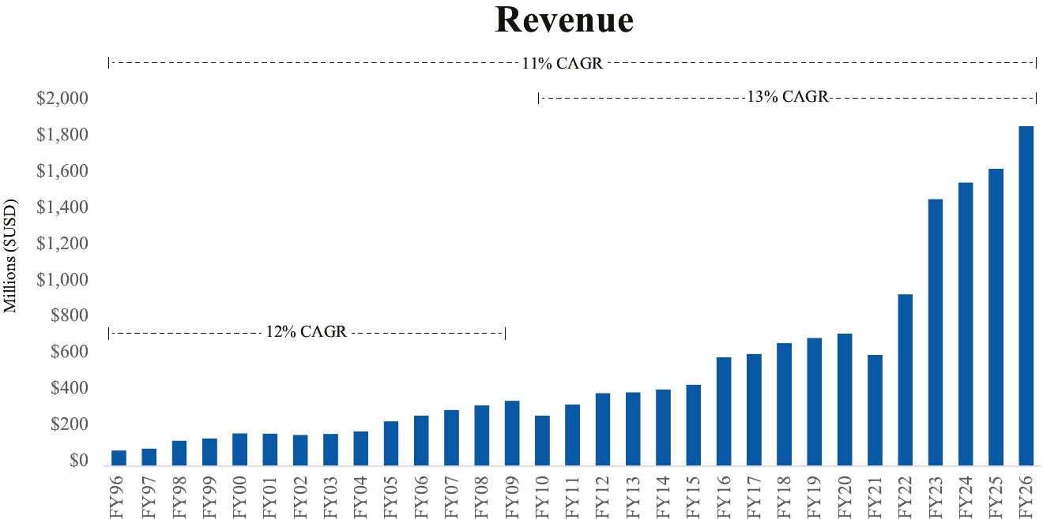

The following graph shows the relationship between revenue CAGR and adjusted EBITDA CAGR for the Company versus our peer group average for fiscal 2022 through fiscal 2026. This reflects substantial revenue growth across our business, including through our acquisition activities. Importantly, the expansion of our profitability (adjusted EBITDA) occurred at a growth rate beyond revenue, reflecting our ability to improve margins as we build the business.
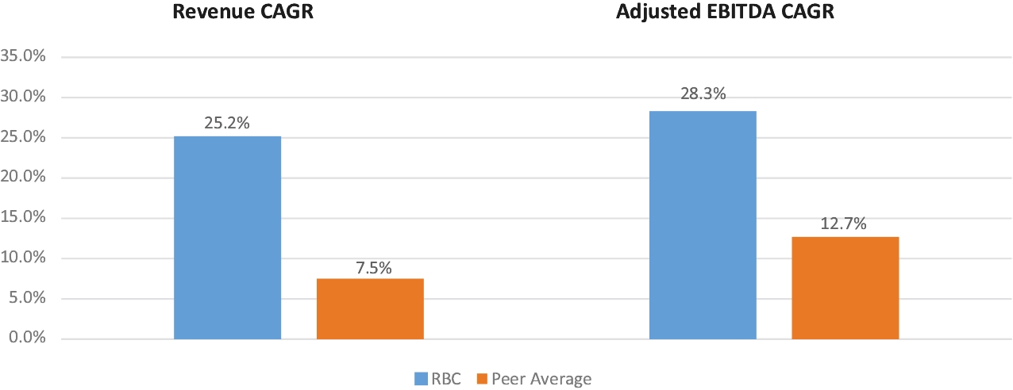

To arrive at adjusted EBITDA of our peer group, we utilized the publicly provided adjusted operating income of peer group members and added back their stock-based compensation expense. Bear in mind that the operating income adjustments that each company makes may or may not be comparable to those made by RBC.
06 |  |  |  |  |  | 2026 Proxy Statement

TABLE OF CONTENTS
The following graph details our total shareholder return (TSR) as compared to our peer group average for fiscal 2022 through fiscal 2026. The TSR calculation includes stock price appreciation and the reinvestment of dividends. Dividends are assumed to be reinvested at the closing price of the stock on the ex-date of the dividend. Our TSR exceeded the peer group average by approximately 78% over this period, driven by the strong operating performance reflected above.
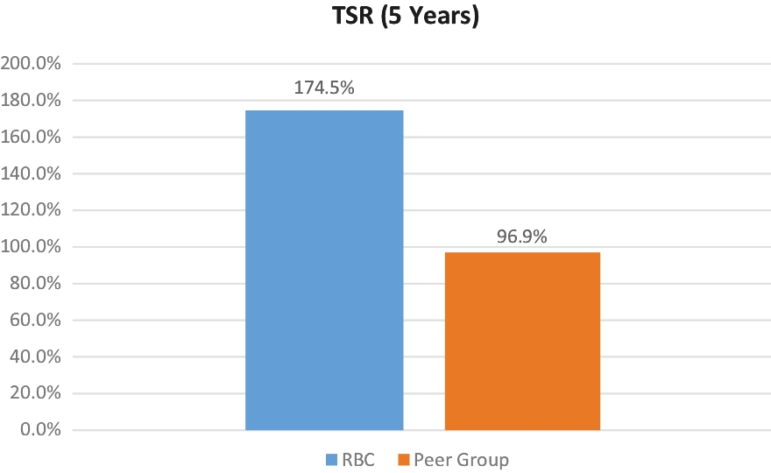

The above information indicates historical results only and is not necessarily indicative of future results.
 |  |  |  |  |  | 2026 Proxy Statement |  |  | 07

TABLE OF CONTENTS

Proposals Submitted for Stockholder Vote
Proposal 1: Election of Directors
The Board currently is composed of nine directors serving staggered three-year terms and divided into Class I, Class II and Class III. This year the Class III directors are up for election and our Nominating and Governance Committee has nominated Dr. Michael J. Hartnett and Dolores J. Ennico for election at the annual meeting, each of whom is an incumbent Class III director. Our third Class III director, Frederick J. Elmy, is retiring from the Board as of the annual meeting, which will result in the Board being reduced to eight directors until the Board takes action to fill Mr. Elmy’s vacancy.
The Nominating and Governance Committee reviewed the qualifications of the Class III nominees and unanimously recommended to the Board that these nominees be submitted for election. We believe that each of Dr. Hartnett and Ms. Ennico has a reputation for integrity, honesty and adherence to high ethical standards. They each have demonstrated business acumen and an ability to exercise sound judgment, as well as a commitment of service to the Company and the Board.
 | Dr. Michael J. Hartnett |  |  | Dr. Hartnett is Chairman, President and Chief Executive Officer of RBC. He holds a Ph.D. in Applied Mechanics from the University of Connecticut. For more information about Dr. Hartnett, see “Directors and Executive Officers” below.
Director since 1992
Age: 81
Skills and Expertise
Dr. Hartnett has been with RBC for more than 30 years and provides the Board with significant leadership and executive experience. See “Board of Directors and Corporate Governance—Director Qualities” below.
 | Dolores J. Ennico |  |  | Ms. Ennico was Chief Human Resources Officer of Olin Corporation prior to her retirement in 2018. She is now Principal of Canterbury Consulting. She holds a Masters Degree in Biochemistry from Southern Connecticut State University. For more information about Ms. Ennico, see “Directors and Executive Officers” below.
Director since 2020
Age: 73
Skills and Expertise
Ms. Ennico has deep knowledge of human capital management, including executive compensation and C-suite experience with a Fortune 500 company. Her perspectives and experience enhance the Board’s oversight of succession planning as well as the Company’s internal development projects and external opportunities. See “Board of Directors and Corporate Governance—Director Qualities” below.
which that person was nominated, (ii) nominate a new candidate in place of such person, in which case the proxy holders will vote for the new candidate, or (iii) leave the place vacant to be filled at a later time.
 |  |  | The Board recommends a vote FOR the election to the Board of Directors of the nominees identified above.

Directors are elected by a majority of the votes of the shares present in person or represented by proxy at the meeting and entitled to vote. If elected at the meeting, each of Dr. Hartnett and Ms. Ennico would serve until the 2029 annual meeting and until a successor is duly elected and qualified, or until his or her resignation or removal. If either of Dr. Hartnett or Ms. Ennico should for any reason become unavailable to serve as a director prior to the annual meeting, the Board will (i) reduce the size of the Board to eliminate the position for
08 |  |  |  |  |  | 2026 Proxy Statement

TABLE OF CONTENTS
Proposal 2: The Ratification of the Appointment of Ernst & Young LLP as the Company’s Independent Registered Public Accounting Firm for Fiscal 2027
Representatives of Ernst & Young are expected to attend the annual meeting, where they will be available to respond to appropriate questions and, if they desire, make a statement.
Ratification of the appointment of Ernst & Young as the Company’s independent registered public accounting firm for fiscal 2027 requires the affirmative vote of a majority of the shares of the Company’s common stock present in person or represented by proxy at the annual meeting and entitled to vote.
The Board recommends a vote FOR the ratification of the appointment of Ernst & Young LLP as the Company’s independent registered public accounting firm for fiscal 2027.

Ernst & Young LLP served as the Company’s independent registered public accounting firm for fiscal 2026 (see “Principal Accountant Fees and Services” below), and the Audit Committee has appointed Ernst & Young to serve in the same capacity for fiscal 2027 and has further directed that the Board submit Ernst & Young’s appointment for ratification by the stockholders at the annual meeting.
While not required, this proposal is being put before the stockholders because the Audit Committee and the Board believe that it is good corporate practice to seek stockholder ratification of the Audit Committee’s appointment of the independent registered public accounting firm. If the appointment of Ernst & Young is not ratified, the Audit Committee will consider the stockholders’ vote, but may ultimately determine to continue Ernst & Young’s engagement or to engage another audit firm without re-submitting the matter to stockholders. Even if the appointment of Ernst & Young is ratified, the Audit Committee may in its sole discretion terminate the engagement and direct the appointment of another independent registered public accounting firm at any time during the year if the Audit Committee determines that such an appointment would be in the best interests of the Company and our stockholders.
 |  |  |  |  |  | 2026 Proxy Statement |  |  | 09

TABLE OF CONTENTS
Proposal 3: Advisory Vote on Executive Compensation
Other Matters to Come Before the Meeting
See “Compensation Discussion and Analysis” below for additional information about our executive officer compensation program.
This proposal gives our stockholders the opportunity to express their views on our named executive officers’ compensation. This vote is not intended to address any specific item of compensation, but rather the overall compensation of our named executive officers and the philosophy, policies and practices described in this proxy statement. Accordingly, we are asking our stockholders to vote FOR the following resolution at the 2026 annual meeting:
“RESOLVED, that the compensation paid to the Company’s named executive officers, as disclosed in the Company’s proxy statement for the 2026 annual meeting of stockholders pursuant to Item 402 of SEC Regulation S-K (including the Compensation Discussion and Analysis, the compensation tables and narrative discussion contained therein), is hereby APPROVED.”
The say-on-pay vote is advisory, and therefore not binding on the Company, the Board or the Compensation Committee. However, the Company, the Board and the Compensation Committee value the opinions of our stockholders and to the extent there is any significant vote against the named executive officers’ compensation as disclosed in this proxy statement, we will consider our stockholders’ concerns and the Compensation Committee will evaluate whether any actions are necessary to address those concerns.
The Board recommends a vote FOR the approval of the compensation of our named executive officers.

The Securities Exchange Act of 1934 requires the Company to hold a non-binding advisory stockholder vote to approve the compensation of our named executive officers as disclosed in this proxy statement in accordance with the SEC’s rules.
The Company’s executive compensation program is designed to reward executives based on favorable performance and results. Compensation policies and plans (including benefits) are designed to attract and retain top quality and experienced executives by providing incentives that promote both the short-term and long-term financial and strategic objectives of the Company. Achievement of short-term objectives is rewarded through base salary and annual cash bonuses, while long-term incentive awards encourage executives to focus on and align themselves with the Company’s long-term goals as well. These incentives are based on financial objectives of importance to the Company, including revenue and earnings growth and creation of stockholder value. The Company’s compensation program also accounts for individual performance, which enables the Company to differentiate among executives and emphasize the link between personal performance and compensation.
The Company is committed to the interests of our stockholders and the delivery of long-term value through an executive compensation program and governance actions that
• | drive outstanding Company performance,
• | align CEO pay with Company performance,
• | ensure that no problematic pay practices exist (e.g., re-pricing or backdating of stock options, excessive perquisites, or tax gross-ups), and
• | reflect appropriate communication with and responsiveness to stockholders.

As of the date of this proxy statement, the Company knows of no business that will be presented for consideration at the 2026 annual meeting other than the three proposals referred to above. If any other matter is properly brought before the meeting for action by stockholders, proxies will be voted in the manner the proxy holder considers appropriate.
10 |  |  |  |  |  | 2026 Proxy Statement

TABLE OF CONTENTS

Board of Directors and Corporate Governance
The Board currently is composed of nine directors serving staggered three-year terms and divided into three classes: Class I consists of Daniel A. Bergeron, Barry C. Boyan and Edward D. Stewart; Class II consists of Richard R. Crowell, Dr. Amir Faghri and Dr. Steven H. Kaplan; and Class III consists of Dr. Michael J. Hartnett, Frederick J. Elmy and Dolores J. Ennico. Class I, Class II and Class III directors will serve until our annual meetings of stockholders in 2028, 2027 and 2026, respectively.
Directors are elected by a majority of the votes of the shares present in person or represented by proxy at the annual stockholders’ meeting and entitled to vote, except in a contested election where directors are elected by a plurality of such votes. Vacancies on the Board may be filled only by persons elected by a majority of the remaining directors. A director elected by the Board to fill a vacancy in a class (including vacancies created by an increase in the number of directors) will serve until the next annual meeting of stockholders and until the director’s successor is duly elected and qualified, or until the director’s resignation or removal.
In our stockholder engagement meetings prior to the 2024 annual meeting, some stockholders expressed a preference for the declassification of our Board. In response, the Board conducted a formal evaluation of the classified board structure that reviewed the costs and benefits of classification and benchmarking of peers and market practices. Following this evaluation, the Board concluded the classified board is the most appropriate structure for the Company at this time in order to promote stability and support our long-term strategy. However, the Board recognizes this is an important topic for some of our stockholders and is committed to regularly reviewing the structure in the future.
Meetings of the Board and Committees of the Board
Director Independence
The Board held four meetings during fiscal 2026. The standing committees of the Board held an aggregate of eight meetings during fiscal 2026. Each director attended at least 75% of the meetings of the Board and the Board committees on which they served during fiscal 2026.
Under the Company’s Corporate Governance Guidelines, the non-employee directors meet in executive sessions on a periodic basis without management.
Directors are encouraged to attend the annual meeting of stockholders. All of the directors attended the 2025 annual meeting of stockholders either in person or by teleconference.
Communications Between Interested Parties and the Board
The rules of the New York Stock Exchange (NYSE) require that the Board be comprised of a majority of “independent” directors, and each of the Company’s Audit Committee, Compensation Committee, and Nominating and Governance Committee be comprised solely of “independent” directors as defined in the NYSE’s rules. Based upon the information submitted by each of the directors, and following the recommendation of the Nominating and Governance Committee, the Board has made a determination that all of our current directors, with the exception of Dr. Hartnett, Mr. Bergeron and Mr. Boyan, satisfy the “independence”
requirements of the NYSE, SEC regulations and the Company’s Corporate Governance Guidelines. The standards for determining independence are those set forth in the NYSE Listed Company Manual and the Company’s Corporate Governance Guidelines. The Company’s Corporate Governance Guidelines can be found on our website at www.investor.rbcbearings.com/corporate-governance/governance-highlights. Mr. Boyan will not be deemed to be independent until the end of 2028, the third anniversary of his retirement from RBC.
Stockholders and any other interested parties may send communications to the Company’s directors as a group or to individual directors (including our Lead Independent Director), by writing to those individuals or the group at the following address: RBC Bearings Incorporated, c/o the Secretary, 102 Willenbrock Road, Oxford, CT 06478. The Secretary will review all correspondence received and will forward all correspondence that is relevant to the duties and responsibilities of the Board or the business of the Company to the intended director(s).
Examples of inappropriate communication include business solicitations, advertising, and communication that is frivolous in nature or relates to routine business matters (such as product inquiries, complaints or suggestions) or raises grievances that are personal to the person submitting the communication. Upon request, any director may review any communication that is not forwarded to the directors pursuant to this policy.
 |  |  |  |  |  | 2026 Proxy Statement |  |  | 11

TABLE OF CONTENTS
Committees of the Board of Directors
The Board has a policy for reporting concerns regarding the Company’s accounting or auditing matters. Reports may be sent to the Audit Committee through either of the following means:
• | calling the Company’s Ethics Hotline at 1-866-247-5449 (which is available 24 hours per day, 365 days per year) and leaving a recorded message, which is transcribed by a third-party service provider to insure the caller’s anonymity, or

• | sending a written communication marked “Private & Confidential” to the Audit Committee, RBC Bearings Incorporated, c/o the Secretary, 102 Willenbrock Road, Oxford, CT 06478.
In either case, the report will be forwarded to the Audit Committee and the confidentiality of the report will be maintained to the extent consistent with applicable law.
The Board currently has an Audit Committee, a Compensation Committee, and a Nominating and Governance Committee. The charter for each of the committees is available on the
Company’s website at www.investor.rbcbearings.com/corporate-governance/governance-highlights.
 | Audit Committee |  |  | Responsible for  • selecting our independent registered public accounting firm,  • approving the overall scope of the audit and the associated fees,  • assisting the Board in monitoring the integrity of our financial statements, the independent registered public accounting firm’s qualifications and independence, the performance of the independent registered public accounting firm and our internal audit function, and our compliance with legal and regulatory requirements,  • annually reviewing the independent registered public accounting firm’s report describing the auditing firms’ internal quality-control procedures, and any material issues raised by the most recent internal quality-control review, or peer review, of the registered public accounting firm,  • discussing the annual audited financial statements and quarterly unaudited financial statements with management and the independent registered public accounting firm,  • discussing earnings press releases, as well as financial information and earnings guidance provided to analysts and rating agencies,  • discussing policies with respect to risk assessment and risk management,  • meeting separately, periodically, with management and the independent registered public accounting firm,  • reviewing with the independent registered public accounting firm any audit issues or difficulties and management’s response,  • setting clear hiring policies for employees or former employees of the independent registered public accounting firm,  • handling such other matters that are specifically delegated to the Audit Committee by the Board from time to time, and  • reporting regularly to the full Board.
Meetings held in fiscal 2026: five

Members:
Richard R. Crowell
Frederick J. Elmy
Edward D. Stewart (Chair)

Each member satisfies the financial literacy requirements of the NYSE and the SEC and the NYSE’s independence requirements for audit committee members.

The Board has determined that Messrs. Crowell, Elmy and Stewart qualify as “audit committee financial experts” for SEC purposes.
 | Compensation Committee |  |  | Responsible for  • reviewing key employee compensation goals, policies, plans and programs,  • reviewing and approving the compensation of our directors, chief executive officer and other executive officers,  • reviewing and approving employment contracts and other similar arrangements between the Company and our executive officers,  • reviewing and consulting with the Board on the selection of the chief executive officer and evaluation of such officer’s executive performance and other related matters,  • administration of stock plans and other incentive compensation plans,  • approving overall compensation policies for the Company, and  • handling such other matters that are specifically delegated to the Compensation Committee by the Board from time to time.
Meetings held in fiscal 2026: one

Members:
Dolores J. Ennico (Chair)
Dr. Amir Faghri
Dr. Steven H. Kaplan

Each member satisfies the NYSE’s independence requirements for compensation committee members.
12 |  |  |  |  |  | 2026 Proxy Statement

TABLE OF CONTENTS
 | Nominating and Governance Committee |  |  | Responsible for  • evaluating the composition, size and governance of the Board and its committees and making recommendations regarding future planning and the appointment of directors to committees,  • considering stockholder nominees for election to the Board,  • evaluating and recommending candidates for election to the Board,  • overseeing the Board’s performance and self-evaluation process and developing continuing education programs for our directors,  • reviewing our corporate governance principles and policies and providing recommendations to the Board regarding possible changes, and  • reviewing and monitoring compliance with the Company’s Code of Conduct and Ethics and our Insider Trading Policy.
Meetings held in fiscal 2026: two

Members:
Dolores J. Ennico
Dr. Steven H. Kaplan
Edward D. Stewart

Each member satisfies the NYSE’s independence requirements for nominating and governance committee members.
Director Qualifications
The Board seeks to have members who possess diverse sets of background, skills and expertise to make a significant contribution to the Board, the Company and our stockholders. In selecting a nominee for the Board, the Nominating and Governance Committee considers the background, skills and expertise that would complement the existing Board, recognizing that the Company’s businesses and operations are diverse and global in nature. Desired qualities for Board members include
• | high-level leadership experience in business or administrative activities, and significant accomplishment,
• | breadth of knowledge about issues affecting the Company,
• | proven ability and willingness to contribute special competencies to Board activities,
• | personal integrity,
• | loyalty to the Company and concern for its success and welfare,
• | ability and willingness to apply sound and independent business judgment,
• | awareness of a director’s vital role in assuring the Company’s good corporate citizenship and corporate image,
• | no present conflicts of interest,

• | availability for meetings and consultation on Company matters, enthusiasm about the prospect of serving,
• | willingness to assume broad fiduciary responsibility, and
• | willingness to become a Company stockholder.
In evaluating candidates, the Nominating and Governance Committee reviews all candidates in the same manner, regardless of the source of the recommendation. The policy of the Committee is to consider individuals recommended by stockholders for nomination as a director in accordance with the procedures described under “Stockholder Proposals and Director Nominations” below.
The Nominating and Governance Committee considers various kinds of diversity when considering whether to nominate an individual for Board membership such as diversity of professional background and capabilities, knowledge of specific industries, and geographic experience. The Board believes it is important that its members represent diverse viewpoints and perspectives in their application of judgment to Company matters. The Nominating and Governance Committee assesses the effectiveness of this objective when evaluating new director candidates and when assessing the composition of the Board.
 |  |  |  |  |  | 2026 Proxy Statement |  |  | 13

TABLE OF CONTENTS
The following matrix identifies the primary experience, qualifications, and skills of each of our directors. This matrix does not encompass all the experience, qualifications or skills of our directors, and the fact that a particular experience, qualification, or skill is not listed does not mean that a director does not possess it. The type and degree of experience, qualifications and skills listed below may vary among the individuals.
 | Experience, Qualifications and Skills |  |  | Michael  Hartnett |  |  | Daniel  Bergeron |  |  | Barry  Boyan |  |  | Richard  Crowell |  |  | Frederick  Elmy |  |  | Dolores  Ennico |  |  | Amir  Faghri |  |  | Steven  Kaplan |  |  | Edward  Stewart
 | Leadership |  |  | ✔ |  |  | ✔ |  |  | ✔ |  |  | ✔ |  |  | ✔ |  |  | ✔ |  |  | ✔ |  |  | ✔ |  |  | ✔
 | Industry Expertise |  |  | ✔ |  |  | ✔ |  |  | ✔ |  |  | ✔ |  |  |  |  |  | ✔ |  |  | ✔
 | Corporate Governance |  |  | ✔ |  |  | ✔ |  |  |  |  |  | ✔ |  |  | ✔ |  |  | ✔ |  |  | ✔ |  |  | ✔ |  |  | ✔
 | Financing/Accounting |  |  | ✔ |  |  | ✔ |  |  |  |  |  | ✔ |  |  | ✔ |  |  |  |  |  |  |  |  |  |  |  | ✔
 | Human Capital Management |  |  | ✔ |  |  | ✔ |  |  | ✔ |  |  |  |  |  | ✔ |  |  | ✔ |  |  | ✔ |  |  | ✔ |  |  | ✔
 | Mergers and Acquisitions |  |  | ✔ |  |  | ✔ |  |  | ✔ |  |  | ✔ |  |  | ✔ |  |  | ✔ |  |  |  |  |  | ✔ |  |  | ✔
 | International Experience |  |  | ✔ |  |  | ✔ |  |  |  |  |  |  |  |  | ✔ |  |  | ✔ |  |  | ✔ |  |  | ✔ |  |  | ✔
 | Risk Management |  |  |  |  |  | ✔ |  |  | ✔ |  |  |  |  |  | ✔ |  |  | ✔ |  |  |  |  |  |  |  |  | ✔
 | Academics & Research |  |  | ✔ |  |  |  |  |  |  |  |  |  |  |  | ✔ |  |  |  |  |  | ✔ |  |  | ✔
 | Technology & Cybersecurity |  |  | ✔ |  |  |  |  |  |  |  |  |  |  |  | ✔ |  |  |  |  |  | ✔
 | Director Attributes
 | Independence |  |  |  |  |  |  |  |  |  |  |  | ✔ |  |  | ✔ |  |  | ✔ |  |  | ✔ |  |  | ✔ |  |  | ✔
Corporate Governance Guidelines
Code of Conduct and Ethics
The Board maintains Corporate Governance Guidelines which, among other things, set forth the Company’s expectations and policies with respect to the roles and responsibilities of the Board, director affiliations and conflicts, director compensation, standards of director conduct, and the qualifications and other criteria for director nominees. The Nominating and Governance Committee is
responsible for periodically reviewing and reassessing the adequacy of these guidelines and recommending changes to the Board for approval. Our Corporate Governance Guidelines are available on the Company’s website at www.investor.rbcbearings.com/corporate-governance/governance-highlights.
Board Risk and Compensation Risk Oversight
The Company’s employees, officers and directors are required to abide by the Company’s Code of Conduct and Ethics, which is intended to ensure that the Company’s business is conducted in a consistently legal and ethical manner. The Code of Conduct and Ethics covers areas of professional conduct such as conflicts of
interest, fair dealing, the protection of confidential information, and compliance with laws, regulations and rules. The Code of Conduct and Ethics is available on the Company’s website at www.investor.rbcbearings.com/corporate-governance/governance-highlights.
The Board has oversight responsibility of the processes established to report and monitor systems for material risks applicable to the Company. The Board focuses on the Company’s general risk management strategy and the most significant risks facing the Company and ensures that appropriate risk mitigation strategies are implemented by management. The Board has delegated to its various committees the oversight of risk management practices for categories of risk relevant to their functions. For example, the Audit Committee oversees risks associated with the Company’s systems of disclosure controls and internal controls over financial reporting, compliance with legal and regulatory requirements, and risks associated with cyber security, foreign exchange, insurance, credit and debt. The Nominating and Governance Committee oversees risks associated with sustainability. The Compensation
Committee considers risks related to the attraction and retention of talent, and risks related to the design of the compensation program. The full Board is responsible for considering strategic risks and succession planning and receives reports from each Committee as to risk oversight within their areas of responsibility.
The Company’s senior management periodically reports on risk management policies and practices to the relevant Board committee or to the full Board so that any decisions can be made as to any required changes to the Company’s risk management and mitigation strategies or to the Board’s oversight of these.
As part of its oversight of the Company’s executive compensation program, the Compensation Committee considers the impact of the Company’s executive compensation program, and the incentives created by the compensation awards that it
14 |  |  |  |  |  | 2026 Proxy Statement

TABLE OF CONTENTS
Board Leadership Structure
administers, on the Company’s risk profile. In addition, the Compensation Committee reviews all of the Company’s compensation policies and procedures, including the incentives that they create and factors that may reduce the likelihood of excessive risk-taking, as well as our executive compensation
clawback policy, to determine whether they present a significant risk to the Company. Based on this review, the Company has concluded that its compensation policies and procedures are not reasonably likely to have a material adverse effect on the Company.
Stockholder Outreach
The Board believes that it should have the flexibility to make decisions as to the Chairman position from time to time in the way that it believes will best provide effective leadership for the Company. Accordingly, the Board periodically reviews its leadership structure, including whether the offices of the Chairman and the Chief Executive Officer should be separate. The Board understands that no single leadership model is right for all companies and at all times, and has therefore not adopted a formal policy with respect to the separation of these offices, which are currently combined. The Board has determined that the current structure is an effective and appropriate leadership structure for the Company at this time.
Because the Chairman is not an independent director, in 2025 the Board established the position of Lead Independent Director, whose duties include
• | coordinating the activities of the independent directors (including having the authority to call meetings of the independent directors and establishing the agenda for such meetings),
• | presiding at executive sessions of the independent directors and presiding at Board meetings in the Chairman’s absence,
• | assisting with the establishment of Board meeting agendas,
• | acting as a liaison between the independent directors and the Chairman, and
• | being available for consultation and direct communication with stockholders if requested.
Richard Crowell currently serves as the Lead Independent Director.
Insider Trading Policy
The Board values its relationship with our stockholders, and periodically engages with them in discussions about our performance and corporate practices, including governance and executive compensation. The feedback received is valuable and helps inform Board decisions. For example, in 2025 the Board
established the position of Lead Independent Director based in part on stockholder feedback. Our most recent stockholder outreach occurred in August 2025. See “Compensation Discussion and Analysis—Stockholder Engagement and Outreach” below.
Hedging Policy
We maintain an insider trading policy that prohibits RBC and our officers, directors and employees from trading or gifting (i) our stock while in possession of material nonpublic information regarding RBC, and (ii) the stock of any of our customers or vendors while in possession of material nonpublic information regarding the customer or vendor. The policy also prohibits trades
or gifts of our stock outside a trading window that opens on the third business day after the release of our financial results for the prior fiscal quarter and closes on the last business day prior to the end of the current quarter. The Insider Trading Policy is filed as Exhibit 19 to our Annual Report on Form 10-K filed May 17, 2024.
Director Compensation
We have a policy that prohibits any director, officer or employee from purchasing, selling or engaging in any other transaction involving any derivative securities that relate to any equity securities of the Company. A “derivative security” includes any option, warrant, convertible security, stock appreciation right or
similar security with an exercise or conversion price or other value that relates to the value of any equity security of the Company (other than any of the foregoing issued pursuant to our long-term equity incentive plans).
Non-employee members of the Board receive an annual cash retainer of $50,000, payable quarterly, and the Chairs of the Compensation and Audit Committees receive an additional $25,000 and $10,000 per year, respectively, for serving in those capacities. Upon the approval of the Board based on the
recommendation of the Compensation Committee, each non-employee director also receives an annual award of restricted stock and stock options having a specified total value with the restricted stock component representing 60% of the value and the stock options making up the remaining 40% of the value
 |  |  |  |  |  | 2026 Proxy Statement |  |  | 15

TABLE OF CONTENTS
(based on the Black-Scholes model). For fiscal 2026 the specified total value of the equity awards was $325,000 per non-employee director. Restricted stock vests over three years, and stock options vest over five years and have an exercise price equal to the closing price of our common stock on the award date. Directors are entitled to reimbursement for reasonable out-of-pocket expenses incurred in connection with attendance at Board and committee meetings.
The specified-value equity component of non-employee director compensation was put in place during fiscal 2025 as a result of
the Compensation Committee’s annual review of such compensation, and replaced the historical practice of making awards of specific numbers of restricted shares and stock options. The new practice is consistent with the Compensation Committee’s approach to equity compensation for the CEO and COO and results in more predictable compensation for non-employee directors.
During fiscal 2026, the non-employee directors received the following compensation:
 | Name |  |  | Fees Earned or  Paid in Cash  ($) |  |  | Stock Awards  ($)(1)(2) |  |  | Option Awards  ($)(1)(3) |  |  | Total  ($)
 | Michael H. Ambrose(4) |  |  | 25,000 |  |  | 195,000 |  |  | 130,000 |  |  | 350,000
 | Barry C. Boyan(5) |  |  | 12,500 |  |  | — |  |  | — |  |  | 12,500
 | Richard R. Crowell |  |  | 50,000 |  |  | 195,000 |  |  | 130,000 |  |  | 375,000
 | Frederick J. Elmy |  |  | 50,000 |  |  | 195,000 |  |  | 130,000 |  |  | 375,000
 | Dolores J. Ennico |  |  | 75,000 |  |  | 195,000 |  |  | 130,000 |  |  | 400,000
 | Dr. Amir Faghri |  |  | 50,000 |  |  | 195,000 |  |  | 130,000 |  |  | 375,000
 | Dr. Steven H. Kaplan |  |  | 50,000 |  |  | 195,000 |  |  | 130,000 |  |  | 375,000
 | Edward D. Stewart |  |  | 60,000 |  |  | 195,000 |  |  | 130,000 |  |  | 385,000
(1) | Computed as the total value to be delivered to each director with 60% being restricted stock and 40% being stock options. The number of shares of restricted stock awarded to each director (532 shares) was determined by dividing the value of the stock award by the $365.87 closing stock price on the date of award. The number of stock options awarded to each director (962 options) was determined by dividing the value of the option award by the fair value of $135.06 utilizing the Black-Scholes model. The award date value does not reflect the actual value that will be received at the time the restricted shares vest or the options are exercised, which value will depend on market conditions at that time.
(2) | At the end of fiscal 2026, the nonemployee directors held the following shares of restricted stock: Mr. Boyan – 1,800; Mr. Crowell – 1,384; Mr. Elmy – 984; Ms. Ennico – 1,384; Dr. Faghri – 1,384; Dr. Kaplan – 1,384; Mr. Stewart – 1,384.
(3) | At the end of fiscal 2026, the nonemployee directors held the following stock options: Mr. Boyan – 7,145; Mr. Crowell – 4,836; Mr. Elmy –1,952; Ms. Ennico – 3,936; Dr. Faghri – 3,936; Dr. Kaplan – 5,336; Mr. Stewart – 5,136.
(4) | Mr. Ambrose retired from the Board on September 4, 2025.
(5) | Mr. Boyan did not become eligible to receive non-employee director compensation until the last quarter of fiscal 2026.
16 |  |  |  |  |  | 2026 Proxy Statement

TABLE OF CONTENTS

CERTAIN RELATIONSHIPS AND RELATED TRANSACTIONS
Since the start of fiscal 2026 the Company has not been a party to, nor have we proposed, any transaction or series of similar transactions in which the amount exceeds $120,000 and in which any director, executive officer, holder of more than 5% of our common stock or any member of the immediate family of any of the foregoing persons had or will have a direct or indirect material interest, other than employment agreements and other compensation arrangements that are described in “Compensation Discussion and Analysis” below. The Company’s directors and executive officers are subject to annual related-party certifications and the Code of Conduct and Ethics requires that an employee or director avoid placing themself in a position in which their personal interests could interfere in any way with the
interests of the Company. While the Company has various controls in place to identify potential related-party transactions, we do not have a formal policy regarding the Board’s review and approval of related party transactions.
We have not made payments to directors other than as described in “Board of Directors and Corporate Governance—Director Compensation” above. We have not made any loans to any director or officer nor have we purchased any shares of our common stock from any director or officer, other than the repurchase of shares from officers at fair market value to cover (i) the exercise price of stock options, and (ii) taxes relating to the receipt of performance-based stock awards, the vesting of shares of restricted stock, and the exercise of stock options.
PRINCIPAL STOCKHOLDERS
Directors and Officers
The following table sets forth information known to the Company regarding beneficial ownership of the Company’s common stock, as of July 7, 2026, by each director, each of our named executive officers, and by all of our directors and executive officers as a
group. Information in the table is derived from SEC filings made by such persons under Section 16(a) of the Exchange Act and other information received by the Company.
 | Name of Beneficial Owner |  |  | Amount and Nature of  Beneficial Ownership(1)(2)(3) |  |  | Percent of  Class(4)
 | Michael J. Hartnett |  |  | 322,388 |  |  | 1.0%
 | Daniel A. Bergeron |  |  | 120,824 |  |  | *
 | Barry C. Boyan |  |  | 8,045 |  |  | *
 | Richard R. Crowell |  |  | 30,535 |  |  | *
 | Frederick J. Elmy |  |  | 1,943 |  |  | *
 | Dolores J. Ennico |  |  | 8,636 |  |  | *
 | Dr. Amir Faghri |  |  | 6,236 |  |  | *
 | Dr. Steven H. Kaplan |  |  | 4,760 |  |  | *
 | Edward D. Stewart |  |  | 23,919 |  |  | *
 | Richard J. Edwards |  |  | 13,458 |  |  | *
 | John J. Feeney |  |  | 5,290 |  |  | *
 | Robert M. Sullivan |  |  | 27,775 |  |  | *
 | All directors, nominees and executive officers as a group (12 persons) |  |  | 573,809 |  |  | 1.8%
(1) | Each person in this table has sole voting and dispositive power with respect to their shares or shares such power with their spouse. None of these shares are held in margin accounts or pledged or otherwise available to a lender as security.
(2) | Includes the following shares of restricted stock held as of July 7, 2026: Dr. Hartnett – 5,722; Mr. Bergeron – 9,176; Mr. Boyan – 2,144; Mr. Crowell – 925; Mr. Elmy – 1,150; Ms. Ennico – 925; Dr. Faghri – 925; Dr. Kaplan – 925; Mr. Stewart – 925; Mr. Edwards – 1,702; Mr. Feeney – 1,180; Mr. Sullivan – 5,833; all directors and executive officers as a group – 31,532.
(3) | Includes the following unissued shares that are subject to stock options that are exercisable within 60 days of July 7, 2026: Dr. Hartnett – 15,200; Mr. Bergeron – 7,000; Mr. Boyan 4,294 – ; Mr. Crowell – 2,882; Mr. Elmy – 390; Ms. Ennico – 1,382; Dr. Faghri – 1,982; Dr. Kaplan – 3,382; Mr. Stewart – 2,582; Mr. Edwards – 2,960; Mr. Feeney – 2,912; Mr. Sullivan – 15,000; all directors and executive officers as a group – 59,966.
(4) | Based on 31,659,666 shares of common stock outstanding as of July 7, 2026 plus the 59,017 unissued option shares referred to in footnote (3).
* | Less than 1.0%.
 |  |  |  |  |  | 2026 Proxy Statement |  |  | 17

TABLE OF CONTENTS
Outside Investors
The following table sets forth each stockholder that, as of July 7, 2026, was known by us to be the beneficial owner of more than 5% of our common stock. Information in the table is derived from SEC filings made by such persons pursuant to Section 13 of the Exchange Act.
 | Name and Address of Beneficial Owner |  |  | Amount and Nature of  Beneficial Ownership |  |  | Percent of  Class(1)
 | BlackRock Inc.  55 East 52nd Street, New York, NY 10055 |  |  | 2,607,586(2) |  |  | 8.2%
 | Durable Capital Partners LP  4747 Bethesda Avenue, Bethesda, MD 20814 |  |  | 2,275,636(3) |  |  | 7.2%
 | Vanguard Capital Management  100 Vanguard Blvd., Malvern, PA 19355 |  |  | 1,656,140(4) |  |  | 5.2%
(1) | Based on 31,659,666 shares of common stock outstanding as of July 7, 2026.
(2) | A Form 13G/A filed January 25, 2024 indicates that it has (i) sole voting power over 2,548,596 shares, (ii) sole dispositive power over 2,607,586 shares, and (iii) shared voting and dispositive power over zero shares.
(3) | A Form 13G/A filed May 15, 2026 indicates that it has (i) sole voting and dispositive power over 2,275,636 shares, and (ii) shared voting and dispositive power over zero shares.
(4) | A Form 13G filed April 30, 2026 indicates that it has (i) sole voting power over 235,617 shares, (ii) sole dispositive power over 1,656,140 shares, and (iii) shared voting and dispositive power over zero shares.
Delinquent Section 16(a) Reports
Section 16(a) of the Exchange Act requires that the Company’s executive officers, directors and greater than 10% stockholders file reports of ownership and changes of ownership of the Company’s common stock with the SEC. Based on a review of ownership reports filed during fiscal 2026, the Company believes that all Section 16(a) filing requirements were met during the year
on a timely basis except that John Feeney’s disposition of 34 shares to the Company (to pay withholding tax on the vesting of restricted stock) on February 8, 2026 was reported one day late, and Richard Crowell’s charitable gift of 4,700 shares on November 4, 2025 was reported on May 20, 2026.
18 |  |  |  |  |  | 2026 Proxy Statement

TABLE OF CONTENTS

Directors and Executive Officers
Directors
 | Dr. Michael J. Hartnett |  |  | Relevant Expertise  Dr. Hartnett provides the Board with significant leadership and executive experience. His proven leadership capability and his strong knowledge of the complex financial and operational issues facing mid-sized companies provides the Board with a unique and necessary perspective.  Dr. Hartnett has developed numerous patents, authored more than two dozen technical papers and is well known for his contributions to the field of tribology, the study of friction.  Career Highlights  • Chairman of the RBC Board since 1993.  • RBC director since 1992.  • President and Chief Executive Officer of RBC since 1992.  • Held a variety of leadership positions elsewhere in the bearing manufacturing industry prior to joining RBC.  Education  • Bachelor of Science, Mechanical Engineering, University of New Haven  • Master’s degree, Worcester Polytechnic Institute  • Ph.D., Applied Mechanics, University of Connecticut
Chairman, President and CEO
Age: 81
 | Daniel A. Bergeron |  |  | Relevant Expertise  Mr. Bergeron’s proven leadership capability and his strong knowledge of the complex financial and operational issues facing mid-sized companies provides the Board with a unique and necessary perspective. Mr. Bergeron provides the Board with significant financial leadership and executive experience.  Career Highlights  • RBC director since 2013.  • Vice President and Chief Operating Officer of RBC since 2017.  • Served as Vice President and Chief Financial Officer from 2003 to 2020.  • Joined RBC in 2003 as Vice President, Finance.  • 15 years of experience with other companies in financial leadership and financial reporting functions prior to joining RBC.  Education  • Bachelor of Science, Finance, Northeastern University  • MBA, University of New Haven
Vice President and COO
Age: 66
 |  |  |  |  |  | 2026 Proxy Statement |  |  | 19

TABLE OF CONTENTS
 | Barry C. Boyan |  |  | Relevant Expertise  Mr. Boyan’s more than 40 years of engineering and management experience in the precision bearing and highly-engineered component manufacturing industries make him a unique and valuable resource to the Board with respect to strategy, organization, manufacturing, technology and risk.  Career Highlights  • RBC director since 2025.  • Vice President and General Manager of RBC’s West Coast business operations from 2001 to 2025.  • 17 years in various engineering and management positions with other bearing manufacturers.  • Licensed Master Electrician.  • United States Marine Corps. veteran.
Non-employee Director
Age: 64
 | Richard R. Crowell |  |  | Relevant Expertise  Mr. Crowell brings broad business, financial and executive leadership experience to the Board developed through his various leadership roles and he has extensive experience with a number of precision manufacturing and aerospace companies. His extensive financial experience also qualifies him as an “audit committee financial expert.”  Career Highlights  • RBC director since 2002.  • Lead Independent Director of the RBC Board since 2025.  • Senior Advisor to Vance Street Capital LLC (a private equity investment firm he founded) since January 2026.  • Managing Partner of Vance Street from 2007 to 2025.  • Spent 24 years in leadership positions in the private equity and investment banking industries prior to founding Vance Street.  Education  • Bachelor of Arts, University of California, Santa Cruz  • MBA, UCLA Anderson School of Business
Lead Independent Director
Age: 71
Board Committees:
• Audit
 | Frederick J. Elmy |  |  | Relevant Expertise  During his nearly 40 years with PricewaterhouseCoopers LLP, Mr. Elmy worked extensively on financial markets transactions, mergers and acquisitions, risk management, technical accounting, and SEC and financial reporting matters. His extensive financial experience qualifies him as an “audit committee financial expert.”  Career Highlights  • RBC director since 2024.  • Joined PwC in 1982, became a partner in 1994, and retired in 2021.  • While with PwC, served in several roles including:  ○ National Office Partner—Accounting and SEC Services;  ○ Audit Partner—Financial Services, Industrial Products and Technology; and  ○ Financial Markets Partner—Accounting Advisory and Treasury Services.  • Executive-in-Residence at Yale University.  Education  • Bachelor of Arts, Economics, University of Pennsylvania  • Certified Public Accountant
Independent Director
Age: 65
Board Committees:
• Audit
20 |  |  |  |  |  | 2026 Proxy Statement

TABLE OF CONTENTS
 | Dolores J. Ennico |  |  | Relevant Expertise  Ms. Ennico has deep knowledge of human capital management, including executive compensation and C-suite experience with a Fortune 500 company. Her perspectives and experience enhance the Board’s oversight of succession planning as well as the Company’s internal development projects and external opportunities.  Career Highlights  • RBC director since 2020.  • Principal of Canterbury Consulting (which provides strategic and business support to organizations on a variety of issues including human capital management, organizational effectiveness, executive compensation and governance) since 2020.  • Chief Human Resources Officer of Olin Corporation from 2009 to 2018 and prior to that served Olin in a variety of capacities from 1974.  • Member of the Board of Governors of the University of New Haven and a member of its Compensation Committee.  • Member of the Executive Committee of the Board of the Girl Scouts of Connecticut.  Education  • Bachelor of Science, Microbiology, Southern Connecticut State University  • Master’s degree, Biochemistry, Southern Connecticut State University  • MBA, University of New Haven
Independent Director
Age: 73
Board Committees:
• Compensation (Chair)
• Nominating and Governance
 | Dr. Amir Faghri |  |  | Relevant Expertise  Dr. Faghri’s extensive experience as a leader in the engineering profession—as an educator, scientist and administrator—along with his associations with U.S. companies and global academic institutions, provides the Company with valuable state-of-the-art resources in engineering, manufacturing and information technology, as well as unparalleled expertise in workforce development.  Career Highlights  • RBC director since 2022 and before that from 2004 to 2020.  • Currently Distinguished Professor Emeritus and Distinguished Dean Emeritus of Engineering at the University of Connecticut.  • Currently Distinguished Adjunct Professor at the University of California, Los Angeles.  • Dean of the University of Connecticut School of Engineering from 1998 to 2006.  • Has served as a consultant to several major research centers and corporations, including Los Alamos and Oak Ridge national laboratories, Exxon Mobil Corporation, and Intel Corporation.  Education  • Bachelor of Science, Oregon State University (highest honors)  • Master’s degree, Mechanical Engineering, University of California, Berkeley  • Ph.D., Mechanical Engineering, University of California, Berkeley
Independent Director
Age: 75
Board Committees:
• Compensation
 |  |  |  |  |  | 2026 Proxy Statement |  |  | 21

TABLE OF CONTENTS
 | Dr. Steven H. Kaplan |  |  | Relevant Expertise  Dr. Kaplan’s knowledge and leadership experience allows Dr. Kaplan to provide the Company with a wealth of valuable international executive experience and a perspective that provides the Board a critical resource for management. His association with U.S. companies and global academia provides the Company with a valuable state of the art executive management resource.  Career Highlights  • RBC director since 2018.  • President Emeritus of the University of New Haven since 2023.  • Served as President of the University of New Haven from 2004 to 2023.  • Prior to the University of New Haven, spent many years in teaching and leadership roles at other universities including the University of Virginia’s College at Wise, the University of Maryland, Eberhard-Karls Universität (Tübingen, Germany), the University of Southern Colorado, the State University of New York at Buffalo and Butler University.  Education  • Bachelor of Arts, University of California, Los Angeles  • Master’s degree, Eberhard-Karls Universität  • Ph.D., Eberhard-Karls Universität
Independent Director
Age: 73
Board Committees:
• Compensation
• Nominating and Governance
 | Edward D. Stewart |  |  | Relevant Expertise  Mr. Stewart’s extensive leadership experience as a senior executive and as a director of other publicly-traded and private companies is an invaluable resource to the Board. His financial experience also qualifies him as an “audit committee financial expert.”  Career Highlights  • RBC director since 2013.  • Former Chairman of the Board of ATC Technology Corporation (a then-publicly-held third-party logistics services provider).  • Has served on other company boards and audit committees.  • Many years of financial and operational experience with General Electric Company prior to his retirement including as Executive Vice President of GE Capital and Chief Financial Officer of a number of other GE businesses.  Education  • Bachelor of Arts, Economics, Tufts University
Independent Director
Age: 83
Board Committees:
• Audit (Chair)
• Nominating and Governance
22 |  |  |  |  |  | 2026 Proxy Statement

TABLE OF CONTENTS
Nondirector Executive Officers
 | Richard J. Edwards |  |  | Career Highlights  Mr. Edwards has been with the Company since 1990 and was appointed Vice President and General Manager for the RBC Division in 1996.  Education  • Bachelor of Science, Management, Arizona State University
Vice President and General Manager
Age: 70
 | John J. Feeney |  |  | Career Highlights  Mr. Feeney joined RBC as Assistant General Counsel in 2014 and in 2020 was appointed Vice President, General Counsel and Secretary. Prior to joining us, he spent 14 years in the legal departments of other corporations and the New York City Law Department.  Education  • Bachelor of Arts, History, St. Joseph’s University  • Master’s degree, St. John’s University  • J.D., SUNY Buffalo School of Law
Vice President, General Counsel and Secretary
Age: 57
 | Robert M. Sullivan |  |  | Career Highlights  Mr. Sullivan joined RBC in 2016 as Assistant Corporate Controller, in 2017 was appointed Corporate Controller, and then in 2020 was appointed Vice President and Chief Financial Officer. Prior to joining us, he spent three years at Sikorsky Aircraft Corporation and six years in Ernst & Young’s audit practice.  Education  • Bachelor of Science, Accounting, Fairfield University  • Master’s degree, Accounting & Taxation, University of Hartford  • MBA, University of Connecticut  • Licensed Certified Public Accountant
Vice President and CFO
Age: 42
 |  |  |  |  |  | 2026 Proxy Statement |  |  | 23

TABLE OF CONTENTS

Compensation Discussion and Analysis
Our named executive officers (NEOs) for fiscal 2026 were:
This Compensation Discussion and Analysis provides a description of our executive compensation philosophy and program, the decisions the Compensation Committee has made
under this program, and the factors considered in making those decisions.
 | Name |  |  | Position
 | Dr. Michael J. Hartnett |  |  | Chairman, President and Chief Executive Officer
 | Daniel A. Bergeron |  |  | Director, Vice President and Chief Operating Officer
 | Richard J. Edwards |  |  | Vice President and General Manager
 | John J. Feeney |  |  | Vice President, General Counsel and Secretary
 | Robert M. Sullivan |  |  | Vice President and Chief Financial Officer

Compensation Philosophy
Pay-for-Performance
The Company’s core focus is on the delivery of sustainable Company performance and long-term stockholder value. The Company’s compensation program is designed to support this focus by incentivizing and rewarding executives for achieving outstanding performance and generating value for our stockholders.
The Company enthusiastically embraces the pay-for-performance philosophy. Over the last several years, we have achieved outstanding performance across numerous metrics,
and we believe this outstanding performance underscores the effectiveness of our compensation program. See “Business Highlights—Operating Performance Highlights” above.
The compensation program is designed to attract and retain top quality and experienced executives by providing the opportunity to earn competitive cash compensation based on corporate, business unit and individual performance, plus the opportunity to accumulate stock-based wealth commensurate with the long-term growth and value created for the Company’s stockholders.
 | What We Do |  |  | What We Don’t Do
 | •  Annual say-on-pay vote  •  Performance-driven compensation philosophy  •  Balance compensation with both short- and long-term incentives using multiple performance measures  •  Set challenging quantitative performance measures  •  Rigorous stock ownership guidelines for executive officers  •  Retain independent compensation consultants as needed  •  Use an appropriate peer group selected based on a range of factors  •  Maintain a clawback policy on all incentive compensation  •  Use double-trigger provisions in the event of a change in control  •  Engage regularly with stockholders on executive compensation  •  Limited perquisites |  |  | •  No executive officer employment agreements, other than for the CEO and COO  •  No guaranteed bonuses or salary increases  •  No re-pricing or backdating of options  •  No share recycling under long-term incentive plans  •  No excessive severance and/or change-in-control provisions  •  No tax “gross-ups”
24 |  |  |  |  |  | 2026 Proxy Statement

TABLE OF CONTENTS
Performance Metrics and the Use of Adjusted EBITDA
Adjusted EBITDA (i.e., our consolidated net income (i) plus interest, taxes, depreciation, amortization and equity-based incentive compensation expense, (ii) plus other non-operating expenses or minus other non-operating income, and (iii) as adjusted for various unusual or non-recurring items) is the core measure used to assess Company operating performance under the variable pay program applicable to our executive officers.
The Company and Compensation Committee believe that adjusted EBITDA is the most appropriate measure of operating performance for a number of reasons, and that, of the various performance metrics we could use under our variable pay program, adjusted EBITDA most closely aligns with our stockholders’ interests. Thus, the Compensation Committee uses adjusted EBITDA performance to determine the majority of the variable compensation of the CEO and COO.
We believe quite strongly that adjusted EBITDA is the most appropriate metric and that its use as the primary performance metric is a significant driver for our outstanding results and stock performance for the following reasons:
• | Our motivation in selecting performance metrics is to choose the metric that most accurately captures our performance as a company and the value that we are generating for our stockholders. We believe that adjusted EBITDA is that metric.
• | Adjusted EBITDA is the foundation on which all of our business units run. Over the years we have developed a strong focus and discipline around cash management and capital allocation from the top of the organization to the bottom. We continue to apply this focus in operating the Company today.
• | Adjusted EBITDA allows management, investors and others to evaluate and compare the Company’s core operating results, including return on capital and operating efficiencies, from period to period by removing the impact of the Company’s capital structure (interest expense from our outstanding debt), asset base (depreciation and amortization), tax consequences, other non-operating items, and share-based compensation.
• | Adjusted EBITDA is the measure that guides the Company, through managing cash flow, operating cost and efficiency, and capital allocation, during periods of economic downturn and inhibits the manipulation of operating performance through excessive leverage or capital expenditures.

• | Adjusted EBITDA is a key driver for debt covenants.
• | We use adjusted EBITDA for business planning purposes, to run the business, for capital allocation decisions, and to evaluate and price potential acquisitions.
• | In addition to its use by management, we also believe adjusted EBITDA is a measure widely used by securities analysts, investors, and others to evaluate the financial performance of the Company and other companies in our industry.
• | We view adjusted EBITDA as the most reliable bellwether of how well we are converting the Company’s revenue into value for our stockholders.
We have relied on adjusted EBITDA as our primary performance metric since our IPO in 2005, when our stock entered the market at $14.50 per share. On July 7, 2026, our stock closed at $600.26 per share.
ROIC (i.e., return on invested capital) is also used as a metric for determining a portion of the CEO and COO’s awards under the equity incentive program. ROIC is defined as adjusted operating income (AOI) divided by equity plus debt less cash, with debt and cash adjusted to eliminate the effects of acquisitions and divestitures. AOI is defined as operating income adjusted to eliminate the effects of asset impairments, restructurings, acquisitions, divestitures, various unusual or non-recurring items, plant closing costs, and the cumulative effect of tax or accounting changes, as determined in accordance with GAAP. The use of ROIC as a performance metric came out of investor feedback that we received in 2017 as well as our belief that ROIC captures not just profitability but whether the magnitude of profitability is appropriate for the investments made. ROIC can also be compared across companies and industries and provides a closer link to key drivers of value creation. We also believe that ROIC works in close synergy with our primary metric of adjusted EBITDA.
Total Shareholder Return (TSR) is an additional metric that the Compensation Committee, following investor feedback in 2024, decided to use for determining a portion of the CEO and COO’s awards under the equity incentive program, starting with awards to be made in fiscal 2028 for the Company’s TSR performance against its peer group average TSR during the trailing five-year period.
 |  |  |  |  |  | 2026 Proxy Statement |  |  | 25

TABLE OF CONTENTS

Stockholder Engagement and Outreach
The Board values its relationship with our stockholders and the feedback they provide the Company. We periodically engage with them to discuss matters affecting the Company, including executive compensation. Stockholder feedback helps inform the decisions of the Board and the Compensation Committee.
Our most recent stockholder engagement took place in August 2025 when the Chair of our Compensation Committee, Dolores J. Ennico, together with our CFO and General Counsel, met with seven stockholders representing over 27% of our outstanding stock, including four of our six largest investors. These stockholders took the opportunity to ask questions regarding multiple topics including corporate governance and succession planning and several noted the positive development that ISS had recommended a vote for our say-on-pay proposal at the upcoming annual meeting where the proposal received approval from 81% of the votes cast.
The Board and Compensation Committee carefully considered the results of this vote when making decisions regarding our executive compensation program. Given the level of support for the proposal, no significant changes were made to the executive compensation program following last year’s vote.
We held an advisory vote on the frequency of future say-on-pay advisory votes (referred to as the “say-on-frequency” vote) at our 2023 annual meeting of stockholders, at which 98% of the votes cast were in favor of holding our say-on-pay votes every year. Based on this outcome, the Board decided that future say-on-pay votes will be conducted every year, although the Board will re-evaluate this decision following the next stockholder advisory say-on-frequency vote, which is expected to occur at our 2029 annual meeting of stockholders, unless presented earlier.
Compensation Program Components and Pay Outcomes for Fiscal 2026
The NEOs’ primary compensation elements are base salary, annual cash performance bonuses, and long-term equity incentive awards in the form of restricted stock, unrestricted stock and/or stock options. In addition, the NEOs participate in our various employee benefit plans and receive certain perquisites.
1. | Base Salary: Base salaries for the executive officers are reviewed annually by the Compensation Committee taking into account a number of factors including the terms of the officer’s employment agreement in the case of the CEO and COO, peer group data, the CEO’s salary recommendations in the case of officers other than the CEO, tenure, performance in role, competitive positioning against market, value to the Company, potential, scope of responsibility, and prior experience.
2. | Annual Performance Bonuses: Cash performance bonuses are paid to the executive officers each year depending on Company performance and, in the case of executive officers other than the CEO and COO, individual performance. The bonuses for the CEO and

COO are prescribed in their employment agreements. The CEO or COO’s bonus for a particular year equals their base salary multiple that corresponds to the Company’s performance level against its adjusted EBITDA plan for the year. The Compensation Committee believes that these bonuses incentivize the CEO and COO to deliver the best possible short-term performance while still maintaining a focus on long-term performance through the other elements of their compensation program.
3. | Long-Term Equity Incentive Awards: The CEO and COO receive annual stock awards based on performance against an adjusted EBITDA target for the year then ended and stock awards based on performance against average adjusted EBITDA and ROIC targets for the three years then ended, although for future periods the three-year average adjusted EBITDA metric is being replaced with performance against the average TSR of the Company’s peer group. Executive officers other than the CEO and COO typically receive an annual award of restricted stock and stock options.

26 |  |  |  |  |  | 2026 Proxy Statement

TABLE OF CONTENTS
Details of the NEOs’ compensation and outcomes for fiscal 2026 are described below.
CEO Compensation Mix
Note About Timing of Presentation of Equity-Based Compensation Data
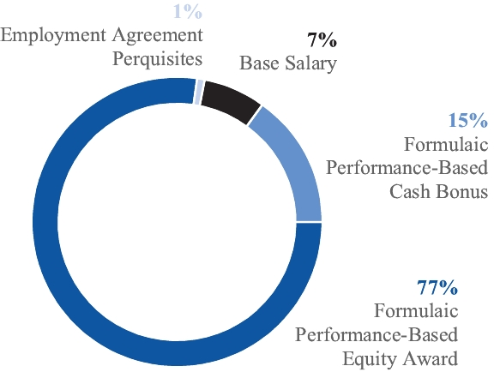

For fiscal 2026, our CEO’s total compensation was $20,912,354, of which $19,176,450 (91.7% of total compensation) was pursuant to performance-based compensation programs. The following pay mix graph demonstrates the focus on performance-based pay for the CEO:
Base Salaries
In June 2024, the Company entered into new employment agreements with the CEO and COO. Financial Accounting Standards Board (FASB) Accounting Standards Codification (ASC) Topic 718 provides that the “grant date” of equity awards under these new agreements is the date the relevant performance plan target is established by the Compensation Committee. However, in the case of equity awards to other NEOs, as well as equity awards to the CEO and COO prior to their new agreements, the “grant date” is the date the award is actually made to the recipient. Because of this difference, compensation reported in this proxy statement for our CEO, COO and other NEOs includes equity awarded in different fiscal years because the compensation tables disclose the full value of the award “granted” in the period.
Specifically, the CEO Compensation Mix chart above, the tables appearing under “Compensation Tables” and “Pay Versus Performance,” and the information in “CEO Pay Ratio” in this proxy statement include the following with respect to fiscal 2026:
• | One-year awards made to the NEOs other than the CEO and COO in fiscal 2026 based on fiscal 2025 performance,
• | One-year awards made to the CEO and COO in fiscal 2027 based on fiscal 2026 performance,
• | Three-year awards made to the CEO and COO in fiscal 2026 based on performance for the three years ending with fiscal 2025, and
• | Three-year awards to be made to the CEO and COO in fiscal 2029 based on performance for the three years ending with fiscal 2028.

The NEOs’ base salaries for fiscal 2026 were, and their base salaries for fiscal 2027 are, as follows:
 |  |  |  | Fiscal 2026  Base Salary |  |  | Fiscal 2027  Base Salary(1) |  |  | Percent  Increase
 | Dr. Michael J. Hartnett |  |  | $1,545,000 |  |  | $1,591,350 |  |  | 3.0%
 | Daniel A. Bergeron |  |  | 692,701 |  |  | 713,482 |  |  | 3.0%
 | Richard J. Edwards |  |  | 395,841 |  |  | 407,716 |  |  | 3.0%
 | John J. Feeney |  |  | 301,404 |  |  | 310,446 |  |  | 3.0%
 | Robert M. Sullivan |  |  | 341,699 |  |  | 355,367 |  |  | 4.0%
(1) | All increases for fiscal 2027 were effective June 1, 2026.
 |  |  |  |  |  | 2026 Proxy Statement |  |  | 27

TABLE OF CONTENTS
Annual Performance Bonuses
Under the Company’s annual incentive compensation plan, the Company pays performance-based annual cash bonuses based on performance for the fiscal year then completed.
CEO and COO
The CEO and COO are eligible for a performance-based cash bonus each year based on the Company’s performance against its adjusted EBITDA plan for the then-completed fiscal year. The bonus equals the multiple of the CEO’s or COO’s fiscal year-end base salary corresponding to the percentage of adjusted EBITDA performance against the plan. For fiscal 2026, the EBITDA performance percentages and salary multiples were:
 | Adjusted EBITDA as a Percentage of Plan |  |  | CEO Bonus as a Multiple  of Base Salary |  |  | COO Bonus as a Multiple  of Base Salary
 | 80.0% to 89.9% |  |  | 0.75x |  |  | 0.45x
 | 90.0% to 99.9% |  |  | 1.0x |  |  | 0.6x
 | 100.0% to 109.9% |  |  | 1.5x |  |  | 0.9x
 | 110.0% to 119.9% |  |  | 2.0x |  |  | 1.2x
 | 120.0% or higher |  |  | 2.5x |  |  | 1.5x
For future fiscal years, the EBITDA performance percentages and salary multiples for the COO will continue to be as set forth above while the CEO’s will be:
 | Adjusted EBITDA as a Percentage of Plan |  |  | CEO Bonus as a Multiple of Base Salary
 | 80.0% to 89.9% |  |  | 0.75x
 | 90.0% to 99.9% |  |  | 1.0x
 | 100.0% to 104.9% |  |  | 2.0x
 | 105.0% to 109.9% |  |  | 2.25x
 | 110.0% or higher |  |  | 3.0x
Executive Officers in Charge of Business Units
For executive officers who are in charge of business units (only Mr. Edwards for fiscal 2026), a range of performance measures beyond adjusted EBITDA are taken into account when determining their annual performance bonuses in order to reflect the areas for which they are directly accountable. These annual performance bonuses are based on the following three-part performance plan:
1. | Divisional sales plus depreciation minus total factory costs for the fiscal year. This component is targeted at 50% of the total annual performance incentive (or 30% of the executive’s fiscal year-end base salary), subject to adjustment based on level of achievement as noted below
 | Percentage of Achievement  of Target Goal |  |  | Amount of Bonus as  Percentage of Target
 | 80.1% to 99.9% |  |  | Pro rata portion of 100%
 | 100.0% |  |  | 100%
 | 100.1% to 119.9% |  |  | Pro rata portion of 200%
 | 120.0% or higher |  |  | 200%

2. | Divisional revenue growth relative to U.S. gross domestic product. This component is equal to 25% of the total target annual performance incentive (or 15% of the executive’s fiscal year-end base salary). This component is earned upon achievement of divisional revenue growth that exceeds two times the U.S. gross domestic product.
3. | Non-financial and qualitative performance goals. This component is equal to 25% of the total target annual performance incentive (or 15% of the executive’s fiscal year-end base salary). The CEO reviews non-financial performance in areas critical to the long-term success of the business.
In addition to annual performance bonuses, the Compensation Committee may approve additional discretionary bonuses to these executive officers in the case of exceptional performance, which is determined by the Committee with the CEO’s input.
28 |  |  |  |  |  | 2026 Proxy Statement

TABLE OF CONTENTS
Other Executive Officers
The annual performance bonuses for any other executive officer (i.e., the CFO and any other officer who is not the CEO or COO or in charge of a business unit), are not made pursuant to a performance plan but are instead based on the Company’s overall performance and the executive officer’s individual performance as evaluated by the Compensation Committee with the CEO’s input, and are determined as a percent of their fiscal year-end base salary.
Fiscal 2026 Performance Bonus Payouts
The adjusted EBITDA goal for fiscal 2026 performance bonuses for the CEO and COO was set at $533.3 million in accordance with the Company’s operating plan for the year, and actual adjusted EBITDA for the year was $605.3 million, which equated to 113.5% of the plan goal. Based on this performance, the Compensation Committee approved the following annual incentive plan payments and discretionary bonuses for fiscal 2026:
 |  |  |  | Performance  Bonus |  |  | Discretionary  Bonus |  |  | Total Bonus |  |  | Bonus as a  Percentage of  Base Salary
 | Dr. Michael J. Hartnett |  |  | $3,090,000 |  |  | NA |  |  | $3,090,000 |  |  | 200.0%
 | Daniel A. Bergeron |  |  | 831,241 |  |  | NA |  |  | 831,241 |  |  | 120.0%
 | Richard J. Edwards |  |  | 95,061(1) |  |  | NA |  |  | 95,061 |  |  | 24.0%
 | John J. Feeney |  |  | NA |  |  | 90,421 |  |  | 90,421 |  |  | 30.0%
 | Robert M. Sullivan |  |  | NA |  |  | 307,529 |  |  | 307,529 |  |  | 90.0%
(1) | Based on achievement of the following performance to target goal under his performance bonus plan: 86.0% of part 1; 0.0% of part 2; 100.0% of part 3.
Long-Term Equity Incentive Awards
Equity Incentive Program for CEO and COO
The Company makes equity awards under its long-term incentive plans, which plans have been approved by the Company’s stockholders. These plans provide for awards of stock, restricted stock, stock options and other types of equity awards for
directors, executive officers and other key employees of the Company. See “Equity Incentive Plans” below. Using equity for long-term incentives provides for strong-stockholder alignment and strong long-term Company performance.
One-Year Performance-Based Stock Component. The one-year component of the program provides the CEO and the COO with an annual award of stock based on the Company’s adjusted EBITDA performance against the plan for the fiscal year then ended. The number of shares awarded equals (i) the officer’s base salary at the end of the fiscal year multiplied by the base salary multiple that corresponds to the Company’s percentage of performance to the plan, divided by (ii) RBC’s closing stock price (see “Closing Stock Price” below). The CEO is awarded shares of unrestricted stock while the COO is awarded shares of restricted stock, which vest and cease to be restricted in one-third increments on each of the first, second and third anniversaries of the award date.
The equity incentive program for the CEO and COO is composed of one-year and three-year performance-based stock awards. The value of each award is equal to the pre-established base salary multiple that corresponds with our level of performance against pre-established financial metrics.
One-year awards are based on performance against the adjusted EBITDA target for the year. The three-year awards for the three-
year period ending with fiscal 2026 were based on performance against previously established adjusted EBITDA and ROIC targets, but awards for the three-year periods ending with fiscal 2027 and subsequent years will be based on performance against ROIC targets and the average TSR of the Company’s peer group.
 |  |  |  |  |  | 2026 Proxy Statement |  |  | 29

TABLE OF CONTENTS
The EBITDA performance percentages and salary multiples used to determine the one-year awards made to the CEO and COO in fiscal 2027 for fiscal 2026 performance were:
 | Adjusted EBITDA as a Percentage of Plan |  |  | CEO Award Value as a Multiple of Base Salary |  |  | COO Award Value as a Multiple of Base Salary
 | 75.0% to 84.9% |  |  | 2.8x |  |  | 1.45x
 | 85.0% to 94.9% |  |  | 3.5x |  |  | 1.9x
 | 95.0% to 104.9% |  |  | 4.5x |  |  | 2.6x
 | 105.0% to 114.9% |  |  | 5.25x |  |  | 3.05x
 | 115.0% or higher |  |  | 6.65x |  |  | 4.85x
The Compensation Committee established an adjusted EBITDA target of $533.3 million for fiscal 2026. Based on our actual results of $605.3 million of adjusted EBITDA (113.5% of plan), in May 2026 Dr. Hartnett was awarded 14,350 shares of stock having an aggregate award date value of $8,110,907 (5.25 times base salary), and Mr. Bergeron was awarded 3,737 shares of stock having an aggregate award date value of $2,112,227 (3.05 times base salary).
For future fiscal years, the EBITDA performance percentages and salary multiples for the COO will continue to be as set forth above while the CEO’s will be:
 | Adjusted EBITDA as a Percentage of Plan |  |  | CEO Award Value as a  Multiple of Base Salary
 | 75.0% to 84.9% |  |  | 2.8x
 | 85.0% to 94.9% |  |  | 3.5x
 | 95.0% to 99.9% |  |  | 4.5x
 | 100.0% to 104.9% |  |  | 5.25x
 | 105.0% or higher |  |  | 6.65x
Three-Year Performance-Based Stock Component. The three-year component of the program provides the CEO and the COO with an annual award of stock based on the Company’s performance during the three-fiscal-year period then ended. The number of shares awarded equals (i) the officer’s base salary at the end of the third fiscal year multiplied by the base salary multiple that corresponds to the Company’s percentage of performance, divided by (ii) RBC’s closing stock price (see “Closing Stock Price” below). The CEO and COO are awarded shares of unrestricted stock.
Awards for the Three Years Ended with Fiscal 2026. The awards made in fiscal 2027 to the CEO and COO for performance in the three-year period ended with fiscal 2026 were based on performance against average adjusted EBITDA and average ROIC targets established by the Compensation Committee early in the period. The performance percentages and salary multiples used to determine the three-year awards were:
 | Average Adjusted EBITDA as a Percentage of Plan |  |  | CEO Award Value as a Multiple of Base Salary |  |  | COO Award Value as a Multiple of Base Salary
 | 75.0% to 84.9% |  |  | 0.6x |  |  | 0.3x
 | 85.0% to 94.9% |  |  | 0.9x |  |  | 0.6x
 | 95.0% to 104.9% (target) |  |  | 1.2x |  |  | 0.8x
 | 105.0% to 114.9% |  |  | 1.65x |  |  | 1.0x
 | 115.0% or higher |  |  | 2.25x |  |  | 1.25x
 | Average ROIC as a Percentage of Plan(1) |  |  | CEO Award Value as a Multiple of Base Salary(1) |  |  | COO Award Value as a Multiple of Base Salary(1)
 | 99.25% |  |  | 0.3x |  |  | 0.2x
 | 100.00% |  |  | 0.6x |  |  | 0.3x
 | 100.75% |  |  | 1.2x |  |  | 0.7x
(1) | In between is straight line.
30 |  |  |  |  |  | 2026 Proxy Statement

TABLE OF CONTENTS
For the three-year period ended with fiscal 2026 the Compensation Committee established average adjusted EBITDA and ROIC targets of $502.1 million and 9.66%, respectively. Based on our actual results of $536.3 million of average adjusted EBITDA over the three years (106.8% of plan) and average ROIC of 9.79% for the three years (101.3% of plan), in May 2026 Dr. Hartnett was awarded 7,790 shares of stock having an aggregate award date value of $4,403,064 (2.85 times base salary), and Mr. Bergeron was awarded 2,082 shares of stock having an aggregate award date value of $1,176,788 (1.7 times base salary).
Awards for Future Three-Year Periods. For three-year periods ending with fiscal 2027 and thereafter, instead of being based on average adjusted EBITDA and ROIC performance as described above, awards will be based on (i) the Company’s five-year trailing TSR against the average TSR of the Company’s peer group as it exists at the start of the three-year period, and (ii) the Company’s performance against average ROIC targets established by the Compensation Committee early in those periods. The performance percentages and salary multiples for these awards are as follows:
 | Trailing Five-Year TSR as a Percentage of Peer Group Average |  |  | CEO Award Value as a Multiple of Base Salary |  |  | COO Award Value as a Multiple of Base Salary
 | 75.0% to 84.9% |  |  | 0.5x |  |  | 0.25x
 | 85.0% to 94.9% |  |  | 0.75x |  |  | 0.5x
 | 95.0% to 104.9% |  |  | 1.0x |  |  | 0.65x
 | 105.0% to 114.9% |  |  | 1.25x |  |  | 0.75x
 | 115.0% or higher |  |  | 1.5x |  |  | 0.85x
 | Average ROIC as a Percentage of Plan(1) |  |  | CEO Award Value as a  Multiple of Base Salary(1)
 | 99.0% |  |  | 1.0x
 | 100.0% |  |  | 2.0x
 | 100.5% |  |  | 4.0x
(1) | In between is straight line.
 | Average ROIC as a Percentage of Plan(1) |  |  | COO Award Value as a  Multiple of Base Salary(1)
 | 99.25% |  |  | 0.4x
 | 100.0% |  |  | 0.6x
 | 100.75% |  |  | 1.75x
(1) | In between is straight line.
Closing Stock Price. In the past, the stock price used to determine the number of shares to be awarded to the CEO and COO under our equity incentive program has been the closing price of our stock on the award date. For future awards, we will use an average of the closing prices during the 180-day period immediately preceding the filing of our annual report on Form 10-K for the year then completed. This change has been made to negate the effect that short-term volatility in our stock price could have on the value of awards.
Performance Targets for Future Awards. Future awards to be made to the CEO and COO under the one-year and three-year components of the performance-based equity program will be based on performance against the Company’s adjusted EBITDA and ROIC plans established by the Compensation Committee early in the relevant performance periods. The Committee has decided that we will not disclose those targets in advance because adjusted EBITDA is the key metric for our performance and disclosure of our targets would provide our competitors insight into our business strategy and could cause us substantial harm.
 |  |  |  |  |  | 2026 Proxy Statement |  |  | 31

TABLE OF CONTENTS
Equity Incentive Program for Other Executive Officers
Equity Incentive Awards for Fiscal 2026
When determining whether to make equity awards to the executive officers, other than the CEO and COO, and when determining the size of any such awards, the Compensation Committee considers a number of factors:
• | Assessments by the CEO and the Compensation Committee of the achievement of applicable performance metrics;
• | The perceived incentive that any award would provide to generate long-term stockholder value; and
• | The contribution of the individual.
For fiscal 2026, the Compensation Committee decided to structure the equity awards to each of the other executive officers
to deliver a specified total value to the officer with restricted stock representing a certain percentage of the value and stock options making up the remainder of the value (based on the Black-Scholes model). Restricted stock and stock options awarded to the other executive officers vest in one-fifth increments over the first five anniversaries of the award date. Stock option exercise prices are set at RBC’s closing stock price on the award date and options expire after seven years. To date all options awarded to executive officers have been non-qualified stock options, not incentive stock options.
The Compensation Committee approved the following awards under the long-term equity incentive plans in fiscal 2027 for performance in fiscal 2026 and the three-year period ended with fiscal 2026:
 |  |  |  | Stock Fair Value(1) |  |  | Stock Options Fair Value(1) |  |  | Total Fair Value
 | Dr. Michael J. Hartnett |  |  | $12,513,971(2) |  |  | NA |  |  | $12,513,971
 | Daniel A. Bergeron |  |  | 3,289,015(3) |  |  | NA |  |  | 3,289,015
 | Richard J. Edwards |  |  | 74,609(4) |  |  | $124,995 |  |  | 199,604
 | John J. Feeney |  |  | 90,435(4) |  |  | 84,065 |  |  | 174,500
 | Robert M. Sullivan |  |  | 696,916(4) |  |  | 502,788 |  |  | 1,199,704
(1) | Fair value of stock awards for the CEO and COO is equal to their salary multiples that correspond to the percentage of performance against the relevant plan targets. Fair value of the stock and option awards for each of the other NEOs is the value that the Compensation Committee determined to deliver to the particular NEO with the value of the stock award representing a certain percentage of the value and the stock option award making up the remainder of the value. The number of shares of stock awarded was determined by dividing the value of the stock award by the $565.22 closing stock price on the date of award. The number of stock options awarded was determined by dividing the value of the option award by the award date fair value of $200.63 utilizing the Black-Scholes model. The award date value does not reflect the actual value that will be received at the time shares of restricted stock vest or options are exercised, which value will depend on market conditions at that time.
(2) | Unrestricted stock.
(3) | $1,176,788 of unrestricted stock and $2,112,227 of restricted stock subject to a 3-year vesting schedule.
(4) | Restricted stock subject to a 5-year vesting schedule.

Benefits and Perquisites
Employee Benefits
In addition to the core elements of executive compensation outlined above (i.e., base salary, performance-based annual cash bonus, and equity awards under the long-term equity incentive
plans), NEOs are eligible for certain additional benefits, perquisites and plans, as described below.
The executive officers are eligible to participate in all our benefit plans generally made available to our employees including medical, dental and vision coverage and life insurance.
Retirement Plans
The executive officers participate in the Company’s 401(k) plan on the same terms and conditions as all other eligible employees. The plan is funded by eligible participants through employee
contributions and by the Company through a 3% non-contributory amount based on earnings plus certain profit sharing and other matching arrangements at certain business units.
32 |  |  |  |  |  | 2026 Proxy Statement

TABLE OF CONTENTS
Perquisite Programs
The Company also maintains a Supplemental Executive Retirement Plan (SERP), a non-qualified supplemental pension plan for executives that provides pension benefits in excess of those provided by the 401(k) plan. The SERP allows eligible employees to elect to defer, until the end of their employment, the
receipt of up to 75% of their salary and up to 100% of their annual bonus. Accounts are paid, either in a lump sum or installments, upon retirement, death or termination of employment. Accounts are generally payable from our general assets and employees’ right to receive payments are subject to the rights of our creditors.
The perquisites provided to the CEO are set out in his employment agreement and include either 20 hours per year of flight time or a $120,000 annual allowance for non-business travel on private aircraft, a leased vehicle, healthcare expense reimbursements, reimbursement of personal expenses of $50,000, healthcare and disability insurance, and an apartment in
Los Angeles for use by Dr. Hartnett while on business. The perquisites provided to the COO are set out in his employment agreement and include a vehicle allowance, and healthcare and disability insurance. Other NEOs may also receive perquisites including reimbursement of certain personal expenses, or a leased vehicle or a vehicle allowance.
Executive Compensation Process and Policies
 | Compensation Committee |  |  | • Oversees the manner in which the Board discharges its responsibilities relating to the Company’s executive compensation program.  • In consultation with the Board, the CEO and senior management, develops and approves the executive compensation philosophy.  • Reviews and approves corporate goals and objectives related to the CEO and COO’s compensation and evaluates their performance.  • Determines the CEO and COO’s compensation and reviews and approves the CEO’s recommendations regarding the compensation of the other executive officers.  • Sole authority to retain executive compensation consultants engaged to provide advice to the Compensation Committee in connection with its responsibilities and to retain other professional advisors when necessary or appropriate.
Dolores J. Ennico (Chair)
Dr. Amir Faghri
Dr. Steven J. Kaplan

Each member satisfies the NYSE’s independence requirements.
 | Outside Compensation Advisor |  |  | • Provides peer group compensation data.  • Provides information regarding compensation best practices.  • Assists with compensation program design.
 | As selected and retained by the Compensation Committee from time to time.
 | Senior Management |  |  | • The CEO, who is in the best position to initially assess performance, makes recommendations to the Compensation Committee regarding compensation decisions regarding the executive officers other than the CEO and COO.  • Senior management provides input and feedback to the Compensation Committee regarding the Compensation Committee’s compensation process and the compensation program design.  • Senior management may be invited to attend Compensation Committee or Board meetings from time to time, or to contribute materials for such meetings.
 | CEO, COO, CFO, General Counsel
 |  |  |  |  |  | 2026 Proxy Statement |  |  | 33

TABLE OF CONTENTS

Compensation Peer Group
The Compensation Committee compares the Company’s senior management compensation levels with those of companies in a group of peer companies selected by the Compensation Committee based on a number of criteria including industry focus, and company scope measured through market capitalization, headcount and financial performance.
The Compensation Committee believes that this customized approach is preferable to an algorithmic GICS code approach to
selecting a peer group, which lacks the precision and ability to take into account unique circumstances that we believe are crucial to devising a fairly representative peer group. The Committee has not made any changes to the peer group this year. Our peer group includes companies in the industrial machinery, aerospace & defense, and electrical components and equipment industries.
 | Peer Group
 | Carlisle Companies Incorporated  Curtiss-Wright Corporation  Dana Incorporated  Enerpac Tool Group Corp.  Flowserve Corporation  Gates Industrial Corporation plc  Graco Inc.  HEICO Corporation |  |  | Hexcel Corporation  ITT Inc.  Regal Rexnord Corp.  Terex Corporation  Textron Inc.  The Timken Company  Woodward, Inc.

Compensation Governance Policies
Compensation Committee Interlocks and Insider Participation. No member of the Compensation Committee has ever been an officer or employee of the Company, or had any relationship with the Company requiring disclosure as a related-party transaction. No executive officer of the Company has served on the board of directors or compensation committee of any other entity that has or has had one or more executive officers who served as a member of the Board or the Compensation Committee during fiscal 2026.
Compensation Clawback Policy. The Company maintains a Compensation Clawback Policy in order to foster a culture that emphasizes integrity and accountability and that reinforces our pay-for-performance compensation philosophy. This policy, which complies with the listing standards of the New York Stock Exchange and SEC regulations, provides that if we need to restate our financial statements (or have a “little r” restatement) and the amount of any incentive-based compensation actually paid or awarded to any executive officer would have been less had it been calculated based on such restated financial statements, then, subject to certain exceptions permitted by the NYSE, the Compensation Committee must seek to recover the pre-tax difference between the amount actually paid and the amount that should have been paid. The Compensation Clawback Policy is filed as Exhibit 97 to our Annual Report on Form 10-K filed May 17, 2024.
Stock Ownership Guidelines. We have adopted stock ownership requirements for each of our executive officers and non-employee directors. These stock ownership requirements are designed to ensure meaningful stock ownership by our executive officers and non-employee directors, thereby aligning their interests with those of our other stockholders. Each executive officer and non-employee director must achieve and maintain ownership of shares of our common stock having a value at least equal to the following:
 | Position |  |  | Value of Stock
 | CEO |  |  | 6x base salary
 | All other executive officers |  |  | 3x base salary
 | Non-employee directors |  |  | 3x annual retainer fee
Our stock ownership program requires the accumulation of stock over a five-year period following the date the person becomes subject to stock ownership requirements. Executive officers who experience a change in base salary have three years from the date of such change to achieve the new level of ownership. Ownership credit is given for restricted stock but not for stock options. The Compensation Committee reviews compliance with these guidelines on an annual basis and as of the end of fiscal 2026 each of our executive officers and non-employee directors was in compliance. The full text of the Company’s Stock Ownership Guidelines is filed as Exhibit 10.1 to our Current Report on Form 8-K dated June 17, 2013.
34 |  |  |  |  |  | 2026 Proxy Statement

TABLE OF CONTENTS
Deductibility of Executive Compensation. Section 162(m) of the Internal Revenue Code generally disallows a tax deduction to a public corporation for compensation over $1,000,000 paid in any fiscal year to its named executive officers. The deductibility of compensation is one of many factors that the Compensation
Committee takes into consideration when designing the Company’s executive compensation program, but the Committee does not have a policy to limit executive compensation to that deductible under Section 162(m).
Compensation Committee Report on Executive Compensation
The Compensation Committee has reviewed and discussed with management the Compensation Discussion and Analysis. Based on that review and discussion, the members of the Compensation Committee recommended to the Board that the Compensation Discussion and Analysis be included in this proxy statement.
Respectfully submitted,
The Compensation Committee of the Board of RBC Bearings Incorporated
Dolores J. Ennico (Chair)
Dr. Amir Faghri
Dr. Steven H. Kaplan
Employment Agreements and Change-in-Control and Severance Arrangements
Employment Agreements With CEO and COO
Change-in-Control Arrangements
In June 2026, the Company and Dr. Hartnett entered into a new employment agreement that amended and restated his prior employment agreement entered into in 2024. The new agreement has an initial term expiring on March 31, 2027 and automatically renews thereafter for successive 12-month periods unless either party gives 90 days’ notice of nonrenewal. The agreement provides, among other things, for (i) a base salary of $1,591,350 per year, (ii) an annual cash performance bonus as described under “Compensation Program Components and Pay Outcome for Fiscal 2026—Annual Performance Bonus—CEO and COO” above, (iii) annual equity incentive awards as described under “Compensation Program Components and Pay Outcome for Fiscal 2026—Long-Term Equity Awards—Equity Incentive Program for CEO and COO” above, and (iv) certain severance benefits as described under “Severance Other Than Following a Change in Control” below. The agreement also contains a change-in-control provision and sets forth certain perquisites Dr. Hartnett is to receive. A copy of Dr. Hartnett’s employment agreement is filed as Exhibit 10.1 to our Current Report on Form 8-K dated June 24, 2026.
Mr. Bergeron’s current employment agreement, which went into effect in 2024 with an initial term expiring on March 31, 2026,
automatically renews each year unless either party gives 90 days’ notice of nonrenewal. The agreement provides, among other things, for (i) a base salary of $713,482 per year, (ii) an annual cash performance bonus as described under “Compensation Program Components and Pay Outcome for Fiscal 2026—Annual Performance Bonus—CEO and COO” above, (iii) annual equity incentive awards as described under “Compensation Program Components and Pay Outcome for Fiscal 2026—Long-Term Equity Awards—Equity Incentive Program for CEO and COO” above, and (iv) certain severance benefits as described under “Severance Other Than Following a Change in Control” below. The agreement also contains a change-in-control provision and sets forth certain perquisites Mr. Bergeron is to receive. A copy of Mr. Bergeron’s employment agreement is filed as Exhibit 10.2 to our Current Report on Form 8-K dated June 28, 2024 and a copy of an amendment to his employment agreement is filed as Exhibit 10.2 to our Current Report on Form 8-K dated June 24, 2026.
The other executive officers do not have employment agreements and are employed “at will.”
Change-in-control compensation arrangements generally protect income for key executives who would likely be involved in decisions regarding and/or successful implementation of merger/acquisition activity and who are at risk for job loss if a takeover of the Company were to occur. We believe it is in the best interests of the Company and our stockholders to have such an agreement with our CEO, COO and certain other executive officers in order (i) for the Board to be able to receive and rely upon
the executive’s advice and counsel as to the best interests of the Company and our stockholders without concern that they might be distracted or influenced by the personal uncertainties and risks created by merger/acquisition proposals or threats, and (ii) to encourage them to remain with the Company and to continue to devote full attention to the Company’s business.
 |  |  |  |  |  | 2026 Proxy Statement |  |  | 35

TABLE OF CONTENTS
The table below summarizes the executive benefits and payments that would have been due to the NEOs upon termination of employment occurring on March 28, 2026 following a change in control:
Each of Dr. Hartnett’s and Mr. Bergeron’s employment agreements provides that in the event of his employment is terminated within 24 months after a change in control of the Company (i.e., a double trigger event), he will be entitled to (i) severance equal to (x) 250% of his annual base salary plus (y) 250% of his annual performance bonus at the target base salary multiple, (ii) a bonus equal to his annual performance bonus at the maximum base salary multiple prorated for the portion of the fiscal year prior to the termination date, and (iii) continued participation in the Company’s welfare benefit programs (at the Company’s expense) for a period of time after his termination.
The Company has entered into a change-in-control letter agreement with Mr. Edwards that provides that if his employment is terminated under certain circumstances within 24 months after a change in control of the Company, he will be entitled to (i) severance equal to (x) 150% of his annual base salary plus (y) 150% of his annual performance bonus at the target level, and (ii) a bonus equal to his annual performance bonus at the maximum level prorated for the portion of the fiscal year prior to the termination date. In addition, he will be entitled to continue
participating in the Company’s welfare benefit programs for up to 18 months following his termination. The letter agreement also commits him to remain employed with the Company in the event of a tender or exchange offer and includes a non-compete covenant for 12 months following his termination following a change in control. The form of the change-in-control letter agreement is filed as Exhibit 10.1 to our Form 10-Q filed February 1, 2010.
None of the other executive officers has a change-in-control arrangement.
The restricted stock held by the executive officers contains a change-in-control provision. If an executive officer is terminated without cause within 18 months after a change in control, all restricted stock will vest on the termination date. In addition, if there is a change in control of the Company or similar event, the Compensation Committee may, in its discretion, provide for the vesting of a participant’s restricted stock and unvested stock options on such terms and conditions as the Committee deems appropriate.
 |  |  |  | Michael J.  Hartnett |  |  | Daniel A.  Bergeron |  |  | Richard J.  Edwards |  |  | John J.  Feeney |  |  | Robert M.  Sullivan
 | Severance Payment |  |  | $9,656,248 |  |  | $3,290,331 |  |  | $950,019 |  |  | NA |  |  | NA
 | Bonus |  |  | 3,862,499 |  |  | 1,039,052 |  |  | 356,257 |  |  | NA |  |  | NA
 | Other Payments |  |  | 39,957 |  |  | 54,002 |  |  | 17,738 |  |  | NA |  |  | NA
 | Stock Options Vesting |  |  | 5,062,968 |  |  | 2,331,630 |  |  | 1,949,580 |  |  | NA |  |  | NA
 | Restricted Stock Vesting |  |  | 11,709,500 |  |  | 6,811,736 |  |  | 1,490,300 |  |  | $851,600 |  |  | $3,385,110
 | Stock Award(1) |  |  | 14,443,225 |  |  | 3,433,145 |  |  | NA |  |  | NA |  |  | NA
 | Total |  |  | $44,774,397 |  |  | $16,959,896 |  |  | $4,763,894 |  |  | $851,600 |  |  | $3,385,110
(1) | See “Severance Other Than Following a Change in Control” below for a description of the stock awards that would be payable to the CEO and COO.
36 |  |  |  |  |  | 2026 Proxy Statement

TABLE OF CONTENTS
Severance Other Than Following a Change in Control
The employment agreements of the CEO and COO provide them with severance if their employment ends, other than following a change in control. No other executive officer has a similar arrangement. The following table summarizes the executive benefits and payments that would have been due to the CEO and COO if their employment had ended on March 28, 2026 other than following a change in control:
 |  |  |  | Michael J. Hartnett |  |  | Daniel A. Bergeron
 | Death or Disability/Termination Without Cause(1)(2)
 | Base Salary |  |  | $1,545,000 |  |  | $692,701
 | Bonus |  |  | 3,862,499 |  |  | 1,039,052
 | Other Payments |  |  | 761,080 |  |  | 103,329
 | Stock Options Vesting |  |  | 5,062,968 |  |  | 2,331,630
 | Restricted Stock Vesting |  |  | 11,709,500 |  |  | 6,811,736
 | Stock Award |  |  | 14,443,225 |  |  | 3,721,771
 | Total |  |  | $37,384,272 |  |  | $14,700,219
 | Termination With Cause/Voluntary Resignation(3)
 | Base Salary |  |  | $772,500 |  |  | NA
 | Other Payments |  |  | 546,795 |  |  | NA
 | Total |  |  | $1,319,295 |  |  | NA
(1) | The employment agreement provides that if his employment ends due to his death, disability or termination by the Company without cause, he will (i) receive (x) a lump-sum payment equal to 12 months of his then-base salary and (y) his annual performance bonus at the maximum base salary multiple prorated for the portion of the fiscal year prior to the termination date, and (ii) be entitled to the continuation of certain benefits for 12 months.
(2) | The employment agreement also provides that if his employment ends due to his death, disability or termination by the Company without cause, (i) all his restricted stock and unvested stock options will vest and (ii) he will receive the following equity awards: (x) the shares not yet issued with respect to performance periods that have then ended; (y) a prorated portion of the shares that would be issuable under the one-year component of his equity incentive program for the performance year in which his employment ends (at the plan target performance percentage) and (z) a prorated portion of the shares that would be issuable under the three-year component of his equity incentive program for any three-year performance periods that are then open (at the plan target performance percentages).
(3) | Dr. Hartnett’s employment agreement provides that if he is terminated for cause or he voluntarily resigns, he will be entitled to his base salary and continuation of certain benefits set forth in his employment agreement for six months following the date of his termination.
 |  |  |  |  |  | 2026 Proxy Statement |  |  | 37

TABLE OF CONTENTS

Compensation Tables
Summary Compensation
The following table sets forth information regarding the compensation of the NEOs in fiscal 2026, 2025 and 2024:
 | Name and  Principal Position |  |  | Fiscal  Year |  |  | Salary  ($)(1) |  |  | Bonus  ($)(2) |  |  | Stock  Awards  ($)(3) |  |  | Option  Awards  ($)(4) |  |  | Non-Equity  Incentive Plan  Compensation  ($)(5) |  |  | All Other  Compensation  ($) |  |  | Total  ($)
 | Michael J. Hartnett  Chairman, President and CEO |  |  | 2026 |  |  | 1,545,000 |  |  | NA |  |  | 16,086,450 |  |  | NA |  |  | 3,090,000 |  |  | 190,904(6) |  |  | 20,912,354
 | Michael J. Hartnett  Chairman, President and CEO |  |  | 2025 |  |  | 1,500,000 |  |  | NA |  |  | 15,619,573 |  |  | NA |  |  | 2,250,000 |  |  | 189,133 |  |  | 19,558,706
 | Michael J. Hartnett  Chairman, President and CEO |  |  | 2024 |  |  | 997,500 |  |  | NA |  |  | 6,317,484 |  |  | NA |  |  | 1,496,250 |  |  | 166,342 |  |  | 8,977,576
 | Daniel A. Bergeron  Vice President and COO |  |  | 2026 |  |  | 692,701 |  |  | NA |  |  | 3,822,413 |  |  | NA |  |  | 831,241 |  |  | 22,931(7) |  |  | 5,369,286
 | Daniel A. Bergeron  Vice President and COO |  |  | 2025 |  |  | 672,525 |  |  | NA |  |  | 4,378,735 |  |  | NA |  |  | 605,273 |  |  | 33,145 |  |  | 5,689,678
 | Daniel A. Bergeron  Vice President and COO |  |  | 2024 |  |  | 640,500 |  |  | NA |  |  | 2,104,431 |  |  | NA |  |  | 576,450 |  |  | 32,461 |  |  | 3,353,842
 | Richard J. Edwards  Vice President and General Manager |  |  | 2026 |  |  | 395,841 |  |  | NA |  |  | 145,984 |  |  | 243,794 |  |  | 95,061 |  |  | 28,381(8) |  |  | 909,061
 | Richard J. Edwards  Vice President and General Manager |  |  | 2025 |  |  | 384,312 |  |  | ​NA |  |  | 219,638 |  |  | 271,039 |  |  | 119,848 |  |  | 28,331 |  |  | 1,023,168
 | Richard J. Edwards  Vice President and General Manager |  |  | 2024 |  |  | 373,118 |  |  | NA |  |  | 199,510 |  |  | 181,380 |  |  | 296,629 |  |  | 27,844 |  |  | 1,078,481
 | John J. Feeney  Vice President, General Counsel and Secretary |  |  | 2026 |  |  | 301,404 |  |  | 90,421 |  |  | 145,984 |  |  | 135,441 |  |  | NA |  |  | 10,875(9) |  |  | 684,125
 |  |  |  | 2025 |  |  | 292,625 |  |  | 90,000 |  |  | 146,425 |  |  | 135,520 |  |  | NA |  |  | 10,707 |  |  | 675,277
 |  |  |  | 2024 |  |  | 282,730 |  |  | 65,000 |  |  | 99,755 |  |  | 90,690 |  |  | NA |  |  | 10,120 |  |  | 548,295
 | Robert M. Sullivan  Vice President and CFO |  |  | 2026 |  |  | 341,699 |  |  | 307,529 |  |  | 656,928 |  |  | 474,043 |  |  | NA |  |  | 10,733(10) |  |  | 1,790,932
 | Robert M. Sullivan  Vice President and CFO |  |  | 2025 |  |  | 325,428 |  |  | 277,800 |  |  | 638,270 |  |  | 467,784 |  |  | NA |  |  | 11,048 |  |  | 1,720,330
 | Robert M. Sullivan  Vice President and CFO |  |  | 2024 |  |  | 243,800 |  |  | 150,000 |  |  | 598,530 |  |  | 453,450 |  |  | NA |  |  | 10,059 |  |  | 1,455,839
(1) | Includes amounts deferred by the officer pursuant to the 401(k) plan and SERP.
(2) | Consists of discretionary bonuses for the fiscal year and paid in the following fiscal year. Performance bonuses paid under the annual incentive plan are included in the “Non-Equity Incentive Plan Compensation” column.
(3) | Represents the aggregate fair value of stock awards to our NEOs, computed in accordance with FASB ASC Topic 718, as follows:
(i) | for the CEO and COO for fiscal 2026 (x) the awards based on fiscal 2026 performance valued at $6,952,500 and $1,801,023, respectively, which were fair value on the date the relevant performance plan target was established by the Compensation Committee in fiscal 2026 assuming target performance (at maximum performance the grant date fair values were $10,274,250 and $3,359,600, respectively; fair values on the award date in fiscal 2027 were $8,110,907 and $2,112,227, respectively), (y) the awards based on performance for the three years ending with fiscal 2025 valued at $4,274,776 and $1,142,690, respectively, which were fair value on the award date in fiscal 2026, and (z) the awards to be made in fiscal 2029 based on performance for the three years ending with fiscal 2028 valued at $4,635,000 and $865,876, respectively, which were fair value on the date the relevant performance plan targets were established by the Compensation Committee in fiscal 2026 assuming target performance (at maximum performance the grant date fair values were $8,497,500 and $1,801,023, respectively);
(ii) | for the CEO and COO for fiscal 2025 (x) the awards based on fiscal 2024 performance valued at $5,027,356 and $1,972,638, respectively, which were fair value on the award date in fiscal 2025, (y) the awards based on fiscal 2025 performance valued at $6,750,000 and $1,748,565, respectively, which were fair value on the date the relevant performance plan target was established by the Compensation Committee in fiscal 2025 assuming target performance (at maximum performance the grant date fair values were $9,975,000 and $3,261,746, respectively; fair values on the award date in fiscal 2026 were $6,750,000 and $1,748,565, respectively), and (z) the three-year awards to be made in fiscal 2028 based on performance for the three years ending with fiscal 2027 valued at $4,500,000 and $840,656, respectively, which were fair value on the date the relevant performance plan targets were established by the Compensation Committee in fiscal 2025 assuming target performance (at maximum performance the grant date fair values were $8,250,000 and $1,748,565, respectively);
(iii) | for the CEO and COO for fiscal 2024, the awards based on fiscal 2023 performance valued at fair value on the award date in fiscal 2024; and
(iv) | for NEOs other than the CEO and COO for each referenced fiscal year, the awards based on performance in the prior fiscal year valued at fair value on the award date in the referenced fiscal year.
While the stock awards for the CEO and COO for performance in three-year periods ending after fiscal 2026 have been valued assuming performance at plan targets, the actual value of these awards when made could be higher or lower, or there could be no awards, depending on the Company’s actual performance during the relevant period. See “Compensation Program Components and Pay Outcomes for Fiscal 2026—Note About Timing of Presentation of Equity-Based Compensation Data” above.
(4) | Represents the fair value on the date of award of non-qualified stock options awarded during the fiscal year based on performance in the prior fiscal year, computed in accordance with FASB ASC Topic 718.
(5) | Consist of annual cash bonuses earned under the annual incentive plan for performance in the fiscal year and paid in the following fiscal year. See “Compensation Program Components and Pay Outcomes for Fiscal 2026—Annual Performance Bonuses” above.
(6) | Includes (i) $170,000 for reimbursement of personal expenses (including aircraft use for personal travel), (ii) $10,800 of Company contributions to his 401(k) account, (iii) $9,321 for reimbursement of healthcare expenses, and (iv) $732 for a Company-owned vehicle.
(7) | Includes (i) $12,000 for a vehicle allowance, (ii) $10,651 of Company contributions to his 401(k) account, and (iii) $229 for taxable costs of group-term life insurance.
(8) | Includes (i) $12,000 for a vehicle allowance, (ii) $10,510 of Company contributions to his 401(k) account, and (iii) $5,881 for taxable costs of group-term life insurance.
(9) | Includes (i) $10,566 of Company contributions to his 401(k) account, and (ii) $258 for taxable costs of group-term life insurance.
(10) | Includes (i) $10,622 of Company contributions to his 401(k) account, and (ii) $60 for taxable costs of group-term life insurance.
38 |  |  |  |  |  | 2026 Proxy Statement

TABLE OF CONTENTS
Grants of Plan-Based Awards
The following table sets forth information regarding (i) potential awards to the NEOs under the Company’s annual performance bonus plans for performance in fiscal 2026, (ii) potential awards to the NEOs under the Company’s equity incentive plans for performance in fiscal 2026 and the three-year period ending with fiscal 2028, and (iii) awards under the Company’s equity incentive plans made to the NEOs in fiscal 2026.
 | Name |  |  | Grant  Date |  |  | Estimated Future Payouts  Under Non-Equity  Incentive Plan Awards(1) |  |  |  |  |  |  |  |  | Estimated Future Payouts  Under Equity  Incentive Plan Awards(2)(3) |  |  |  |  |  |  |  |  | All Other  Stock  Awards:  Number of Shares of  Stock or  Units  (#) |  |  | All Other  Option  Awards:  Number of  Securities  Underlying  Options  (#) |  |  | Exercise  or Base  Price of  Option  Awards  ($/Sh) |  |  | Grant  Date Fair  Value of  Stock and  Stock  Option  Awards(4)  ($)
 |  |  |  |  |  |  | Threshold  ($) |  |  | Target  ($) |  |  | Maximum  ($) |  |  | Threshold  (#) |  |  | Target  (#) |  |  | Maximum  (#)
 | Michael J.  Hartnett |  |  |  |  |  | 1,158,750 |  |  | 2,317,500 |  |  | 3,862,499
 | Michael J.  Hartnett |  |  | 3/30/25 |  |  |  |  |  |  |  |  |  |  |  | ​2,373 |  |  | ​4,745 |  |  | ​7,118 |  |  | NA |  |  | NA |  |  | NA |  |  | 1,769,174
 | Michael J.  Hartnett |  |  | 5/28/25 |  |  |  |  |  |  |  |  |  |  |  |  |  |  |  |  |  |  |  |  | 11,713 |  |  | NA |  |  | NA |  |  | 4,274,776
 | Michael J.  Hartnett |  |  | ​6/27/25 |  |  |  |  |  |  |  |  |  |  |  | 15,395 |  |  | 26,333 |  |  | 43,146 |  |  | ​NA |  |  | NA |  |  | NA |  |  | ​10,042,500
 | Daniel A Bergeron |  |  |  |  |  | 311,716 |  |  | 623,431 |  |  | 1,039,052 |  |  | ​ |  |  | ​ |  |  | ​
 | Daniel A Bergeron |  |  | 3/30/25 |  |  |  |  |  |  |  |  |  |  |  | 532 |  |  | 1,383 |  |  | 1,808 |  |  | NA |  |  | NA |  |  | NA |  |  | 463,080
 | Daniel A Bergeron |  |  | 5/28/25 |  |  |  |  |  |  |  |  |  |  |  | ​ |  |  | ​ |  |  | ​ |  |  | 3,131 |  |  | NA |  |  | NA |  |  | 1,142,690
 | Daniel A Bergeron |  |  | 6/27/25 |  |  |  |  |  |  |  |  |  |  |  | 3,360 |  |  | 5,812 |  |  | 11,988 |  |  | NA |  |  | NA |  |  | NA |  |  | 2,216,643
 | Richard J.  Edwards |  |  |  |  |  | 59,376 |  |  | 237,505 |  |  | 356,257 |  |  | NA |  |  | NA |  |  | NA
 | Richard J.  Edwards |  |  | 5/28/25 |  |  |  |  |  |  |  |  |  |  |  |  |  |  |  |  |  |  |  |  | 400 |  |  | 1,800 |  |  | 364.96 |  |  | 389,778
 | John J. Feeney |  |  |  |  |  | NA |  |  | NA |  |  | NA |  |  | NA |  |  | NA |  |  | NA
 | John J. Feeney |  |  | 5/28/25 |  |  |  |  |  |  |  |  |  |  |  |  |  |  |  |  |  |  |  |  | 400 |  |  | 1,000 |  |  | 364.96 |  |  | 281,425
 | Robert M. Sullivan |  |  |  |  |  | NA |  |  | NA |  |  | NA |  |  | NA |  |  | NA |  |  | NA
 | Robert M. Sullivan |  |  | 5/28/25 |  |  |  |  |  |  |  |  |  |  |  |  |  |  |  |  |  |  |  |  | 1,800 |  |  | 3,500 |  |  | 364.96 |  |  | 1,130,971
(1) | See “Compensation Discussion and Analysis—Compensation Program Components and Pay Outcomes for Fiscal 2026—Annual Performance Bonuses” above for a description of the annual non-equity incentive plans for the NEOs.
(2) | See “Compensation Discussion and Analysis—Compensation Program Components and Pay Outcomes for Fiscal 2026—Long-Term Equity Incentive Awards—Equity Incentive Program for CEO and COO” above for a description of the equity incentive plans for the NEOs.
(3) | The number of shares awardable is determined by dividing the value of the award by our closing stock price on the grant date of the award.
(4) | The grant date fair value of the stock and/or option awards granted to our NEOs, as computed in accordance with FASB ASC Topic 718.
 |  |  |  |  |  | 2026 Proxy Statement |  |  | 39

TABLE OF CONTENTS
Outstanding Equity Awards at End of Fiscal 2026
As of the end of fiscal 2026 the NEOs held the following equity awards:
 |  |  |  | Option Awards |  |  |  |  |  |  |  |  |  |  |  | Stock Awards
 | Name |  |  | Number of  securities  underlying  unexercised  options (#)  exercisable |  |  | Number of  securities  underlying  unexercised  options (#)  unexercisable |  |  | Option  exercise  price  ($) |  |  | Option  expiration  date |  |  | Number of  shares or  units of  stock that  have not  vested  (#) |  |  | Market  value of  shares or  units of  stock that  have not  vested  ($)(1) |  |  | Equity  incentive  plan awards:  number of  unearned  shares that  have not  vested  (#) |  |  | Equity  Incentive  Plan Awards:  market value  of unearned  shares that  have not  vested  ($)
 | Michael J. Hartnett |  |  | - |  |  | 15,200(2) |  |  | 199.16 |  |  | 6/3/28 |  |  | 10,555(2) |  |  | 5,617,899 |  |  | 11,611(3) |  |  | 6,180,000
 | Michael J. Hartnett |  |  |  |  |  |  |  |  |  |  |  |  |  |  | 11,445(4) |  |  | 6,091,601 |  |  | 4,227(5) |  |  | 2,250,000
 | Michael J. Hartnett |  |  |  |  |  |  |  |  |  |  |  |  |  |  |  |  |  |  |  |  | 11,611(6) |  |  | 6,180,000
 | Michael J. Hartnett |  |  |  |  |  |  |  |  |  |  |  |  |  |  |  |  |  |  |  |  | 3,626(7) |  |  | 1,930,000
 | Daniel A. Bergeron |  |  | - |  |  | 7,000(2) |  |  | 199.16 |  |  | 6/3/28 |  |  | 3,516(2) |  |  | 1,871,391 |  |  | 2,278(3) |  |  | 1,212,227
 | Daniel A. Bergeron |  |  |  |  |  |  |  |  |  |  |  |  |  |  | 4,491(4) |  |  | 2,390,335 |  |  | 1,084(5) |  |  | 577,000
 | Daniel A. Bergeron |  |  |  |  |  |  |  |  |  |  |  |  |  |  | 4,791(8) |  |  | 2,550,010 |  |  | 2,278(6) |  |  | 1,212,227
 | Daniel A. Bergeron |  |  |  |  |  |  |  |  |  |  |  |  |  |  |  |  |  |  |  |  | 939(7) |  |  | 500,000
 | Richard J. Edwards |  |  | - |  |  | 1,000(2) |  |  | 199.16 |  |  | 6/3/28 |  |  | 400(2) |  |  | 212,900
 | Richard J. Edwards |  |  | - |  |  | 1,600(9) |  |  | 199.10 |  |  | 6/3/29 |  |  | 800(9) |  |  | 425,800
 | Richard J. Edwards |  |  | - |  |  | 1,200(10) |  |  | 199.51 |  |  | 6/1/30 |  |  | 600(10) |  |  | 319,350
 | Richard J. Edwards |  |  | - |  |  | 1,600(11) |  |  | 292.85 |  |  | 5/23/31 |  |  | 600(11) |  |  | 319,350
 | Richard J. Edwards |  |  | - |  |  | 1,800(12) |  |  | 364.96 |  |  | 5/28/32 |  |  | 400(12) |  |  | 212,900
 | John J. Feeney |  |  | 112 |  |  | - |  |  | 181.58 |  |  | 2/8/28 |  |  | - |  |  | -
 | John J. Feeney |  |  | 400 |  |  | 400(2) |  |  | 199.16 |  |  | 6/3/28 |  |  | 100(2) |  |  | 53,225
 | John J. Feeney |  |  | 400 |  |  | 800(9) |  |  | 199.10 |  |  | 6/3/29 |  |  | 400(9) |  |  | 212,900
 | John J. Feeney |  |  | 400 |  |  | 600(10) |  |  | 199.51 |  |  | 6/1/30 |  |  | 300(10) |  |  | 159,675
 | John J. Feeney |  |  | 200 |  |  | 800(11) |  |  | 292.85 |  |  | 5/25/31 |  |  | 400(11) |  |  | 212,900
 | John J. Feeney |  |  | - |  |  | 1,000(12) |  |  | 364.96 |  |  | 5/28/32 |  |  | 400(12) |  |  | 212,900
 | Robert M. Sullivan |  |  | 2,000 |  |  | - |  |  | 137.44 |  |  | 6/2/27 |  |  | - |  |  | -
 | Robert M. Sullivan |  |  | 4,000 |  |  | 1,000(2) |  |  | 199.16 |  |  | 6/3/28 |  |  | 200(2) |  |  | 106,450
 | Robert M. Sullivan |  |  | 2,400 |  |  | 1,600(9) |  |  | 199.10 |  |  | 6/3/29 |  |  | 800(9) |  |  | 425,800
 | Robert M. Sullivan |  |  | 2,000 |  |  | 3,000(10) |  |  | 199.51 |  |  | 6/1/30 |  |  | 1,800(10) |  |  | 958,050
 | Robert M. Sullivan |  |  | 400 |  |  | 1,600(11) |  |  | 292.85 |  |  | 5/23/31 |  |  | 800(11) |  |  | 425,800
 | Robert M. Sullivan |  |  | 300 |  |  | 1,200(13) |  |  | 287.85 |  |  | 11/5/31 |  |  | 960(13) |  |  | 510,960
 | Robert M. Sullivan |  |  | - |  |  | 3,500(12) |  |  | 364.96 |  |  | 5/28/32 |  |  | 1,800(12) |  |  | 958,050
(1) | Based on $532.25, the closing price of our common stock on March 27, 2026, the last business day of fiscal 2026.
(2) | Vested in June 2026.
(3) | Shares to be awarded in fiscal 2028 based on the Company’s average ROIC performance for the three years ending with fiscal 2027.
(4) | One-half vested in May 2026, and the other half will vest in May 2027.
(5) | Shares to be awarded in fiscal 2028 based on the Company’s TSR performance for the five years ending with fiscal 2027.
(6) | Shares to be awarded in fiscal 2029 based on the Company’s average ROIC performance for the three years ending with fiscal 2028.
(7) | Shares to be awarded in fiscal 2029 based on the Company’s TSR performance for the five years ending with fiscal 2028.
(8) | One-third vested in May 2026 and the other two-thirds will vest in equal increments in May 2027 and May 2028.
(9) | One-half vested in June 2026 and the other half will vest in June 2027.
(10) | One-third vested in June 2026 and the other two-thirds will vest in equal increments in June 2027 and June 2028.
(11) | One-quarter vested in May 2026 and the other three-quarters will vest in equal increments in May 2027, May 2028 and May 2029.
(12) | One fifth vested in May 2026 and the other four-fifths will vest in equal increments in May 2027, May 2028, May 2029 and May 2030.
(13) | One-fifth vested in November 2025 and the other four-fifths will vest in November 2026, November 2027, November 2028 and November 2029.
40 |  |  |  |  |  | 2026 Proxy Statement

TABLE OF CONTENTS
Option Exercises and Stock Vested in Fiscal 2026
The following table sets forth information regarding the NEOs’ exercises of stock options and vesting of restricted stock during fiscal 2026:
 |  |  |  | Option Awards |  |  |  |  |  | Stock Awards
 | Name |  |  | Number of  Shares Acquired  on Exercise (#) |  |  | Value Realized  on Exercise ($)(1) |  |  | Number of  Shares  Vesting (#) |  |  | Value Realized  on Vesting ($)(2)
 | Michael J. Hartnett |  |  | 26,978 |  |  | 5,635,443 |  |  | 56,505 |  |  | 20,654,578
 | Daniel A. Bergeron |  |  | 83,743 |  |  | 19,480,306 |  |  | 12,817 |  |  | 4,689,847
 | Richard J. Edwards |  |  | 2,600 |  |  | 884,113 |  |  | 1,150 |  |  | 423,308
 | John J. Feeney |  |  | - |  |  | - |  |  | 590 |  |  | 232,589
 | Robert M Sullivan |  |  | - |  |  | - |  |  | 2,140 |  |  | 799,075
(1) | Based on the closing price of our common stock on the date of exercise.
(2) | Based on the closing price of our common stock on the date of vesting.
Non-Qualified Deferred Compensation
The following table sets forth information regarding the NEOs’ deferral of compensation through contributions to our SERP during fiscal 2026:
 | Name |  |  | Executive  Contributions  in Last Fiscal  Year  ($)(1) |  |  | Registrant Contributions  in Last Fiscal  Year  ($) |  |  | Aggregate  Earnings in  Last Fiscal  Year  ($)(2) |  |  | Aggregate  Withdrawals/  Distributions  ($) |  |  | Aggregate  Balance at  Last Fiscal  Year End  ($)
 | Michael J. Hartnett |  |  | - |  |  | - |  |  | 80,190 |  |  | - |  |  | 1,082,318
 | Daniel A. Bergeron |  |  | - |  |  | - |  |  | 272,365 |  |  | - |  |  | 2,354,288
 | Richard J. Edwards |  |  | 25,497 |  |  | - |  |  | 53,215 |  |  | - |  |  | 684,731
 | John J. Feeney |  |  | - |  |  | - |  |  | 37,563 |  |  | - |  |  | 344,307
 | Robert M. Sullivan |  |  | - |  |  | - |  |  | 34,231 |  |  | - |  |  | 269,100
(1) | These amounts are included in the “Salary” column in the Summary Compensation table.
(2) | Appreciation and earnings on the NEO’s account under the SERP.
Potential Payments Upon Termination or Change in Control
See “Employment Agreements and Change-in-Control and Severance Arrangements” above for information about amounts payable to NEOs in the event of their termination or a change in control of the Company.
 |  |  |  |  |  | 2026 Proxy Statement |  |  | 41

TABLE OF CONTENTS

Pay Versus Performance
The following Pay Versus Performance (PVP) table provides information about compensation for our NEOs for each of fiscal 2026, 2025, 2024, 2023 and 2022 (the “Covered Years”). The PVP table also provides information about the results for certain financial performance measures during the Covered Years. In reviewing this information, there are a few important things to consider:
• | The information in columns (b) and (d) comes directly from the Summary Compensation table (SCT) in this proxy statement, without adjustment.
• | As required by the PVP regulations, we describe the information in columns (c) and (e) as “compensation actually paid” (CAP) to the applicable NEOs, but these CAP amounts do not necessarily reflect compensation that our NEOs actually earned for their service in the Covered Years. Instead, CAP is a calculation involving a combination of realized pay (for cash amounts and some equity award amounts) and realizable or accrued pay (primarily for pension benefits and other equity awards).
• | The PVP regulations require that we choose a peer group or index for purposes of TSR comparisons, and we have chosen the S&P 400 Industrials Sector (the “PVP Peer Index”) for this purpose. Note that the PVP Peer Index is different from the Company’s peer group referred to in other parts of this proxy statement including in the description of the TSR-based equity awards for the CEO and COO (see “Compensation Discussion and Analysis—Compensation Peer Group” above).
• | As required by the PVP regulations, we provide information about our cumulative TSR, cumulative PVP Peer Index TSR and U.S. GAAP net income results (the “External Measures”) during the Covered Years in the PVP table, but we did not actually base any compensation decisions for the NEOs on, or link any NEO pay to, the External Measures.
The Company is required to designate one financial metric as the “Company-Selected Measure,” or the most important financial measure that demonstrates how the Company sought to link 2026 executive pay to performance. For 2026, the Company has selected adjusted EBITDA. However, the Company believes that all of the metrics designated in the “Important Financial Performance Measures” section below are important drivers of Company performance.
42 |  |  |  |  |  | 2026 Proxy Statement

TABLE OF CONTENTS
Pay Versus Performance(1)
Value of initial fixed $100
Investment based on:
 | Fiscal  Year  (a) |  |  | Summary  Compensation  Table “SCT”  Total for PEO  (b) |  |  | Compensation  Actually Paid  to PEO  (c)(2)(3) |  |  | Average Summary  Compensation  Table Total for  non-PEO NEOs  (d) |  |  | Average  Compensation  Actually Paid  to non-PEO  NEOs  (e)(2) |  |  | Total  Shareholder  Return  (f)(4) |  |  | PVP Peer  Index Total  Shareholder  Return  (g)(4) |  |  | Net  Income  (h)(5) |  |  | Adjusted  EBITDA  (i)(5)(6)
 | 2026 |  |  | $20,912,354 |  |  | $38,676,976 |  |  | $2,188,352 |  |  | $5,433,365 |  |  | $268.5 |  |  | $172.5 |  |  | $287.6 |  |  | $605.3
 | 2025 |  |  | $19,558,706 |  |  | $26,092,862 |  |  | $2,277,113 |  |  | $3,512,610 |  |  | $295.9 |  |  | $263.0 |  |  | $246.2 |  |  | $519.8
 | 2024 |  |  | $8,977,576 |  |  | $12,753,252 |  |  | $1,609,114 |  |  | $2,003,000 |  |  | $245.8 |  |  | $283.9 |  |  | $209.9 |  |  | $482.1
 | 2023 |  |  | $8,450,217 |  |  | $14,352,594 |  |  | $1,684,877 |  |  | $2,647,801 |  |  | $211.6 |  |  | $209.7 |  |  | $166.7 |  |  | $433.9
 | 2022 |  |  | $19,404,363 |  |  | $18,435,256 |  |  | $3,068,308 |  |  | $2,923,082 |  |  | $177.8 |  |  | $201.6 |  |  | $54.7 |  |  | $266.5
(1) | Dr. Michael J. Hartnett was our principal executive officer (PEO) for each of the Covered Years. In this disclosure, we refer to our NEOs other than Dr. Hartnett as our “other NEOs.” Daniel A. Bergeron, Richard J. Edwards, John J. Feeney and Robert M. Sullivan were our other NEOs for each of the Covered Years.
(2) | In calculating the CAP amounts reflected in these columns, the fair value or change in fair value, as applicable, of the equity award adjustments included in such calculations was computed in accordance with FASB ASC Topic 718. The valuation assumptions used to calculate such fair values did not materially differ from those disclosed at the time of grant. For each Covered Year, in determining the CAP for our PEO and the average CAP for our other NEOs, we deducted or added back the following amounts from or to the total amounts of compensation reported in column (b) and column (d) for such Covered Year:
 | Item and Value Added (or Deducted) |  |  | 2026 |  |  | 2025 |  |  | 2024 |  |  | 2023 |  |  | 2022
 | For Dr. Hartnett:
 | - change in actuarial present value of pension benefits, as reported in SCT for Covered Year |  |  | - |  |  | - |  |  | - |  |  | - |  |  | -
 | + service cost of pension benefits, as calculated for Covered Year |  |  | - |  |  | - |  |  | - |  |  | - |  |  | -
 | + prior service cost of pension benefits, as calculated for Covered Year |  |  | - |  |  | - |  |  | - |  |  | - |  |  | -
 | - SCT “Stock Awards” column value |  |  | (16,086,450) |  |  | (15,619,573) |  |  | (6,317,484) |  |  | (5,984,946) |  |  | (10,364,286)
 | - SCT “Option Awards” column value |  |  | - |  |  | - |  |  | - |  |  | - |  |  | (5,820,840)
 | +/- adjusted amount for applicable stock/option awards, as calculated for Covered Year |  |  | 33,851,072 |  |  | 22,153,729 |  |  | 10,093,160 |  |  | 11,887,323 |  |  | 15,216,019
 | + the Covered Year-end fair value of equity awarded in (and still outstanding as of the end of) the Covered Year |  |  | 8,107,409 |  |  | 10,183,010 |  |  | 8,560,633 |  |  | 6,995,864 |  |  | 16,179,662
 | +/- the change in fair value of equity awarded in prior Covered Years (and still outstanding as of the end of the Covered Year) |  |  | 11,248,342 |  |  | 3,414,310 |  |  | 3,925,511 |  |  | 4,844,811 |  |  | (827,571)
 | + the vesting date fair value of equity awarded and vested in the Covered Year |  |  | 12,386,026 |  |  | 6,750,000 |  |  | - |  |  | - |  |  | -
 | +/- the change in fair value of equity awarded in prior Covered Years that vested in the Covered Year |  |  | 2,109,295 |  |  | 1,806,409 |  |  | (2,392,984) |  |  | 46,648 |  |  | (136,072)
 | - prior the Covered Year-end fair value of equity awarded in prior Covered Years that were forfeited in the Covered Year |  |  | - |  |  | - |  |  | - |  |  | - |  |  | -
 | + dividends/earnings paid or accrued on equity awarded during or for the Covered Year (if not otherwise included in CAP) |  |  | - |  |  | - |  |  | - |  |  | - |  |  | -
 | Total Added (or Deducted): |  |  | 17,764,622 |  |  | 6,534,156 |  |  | 3,775,676 |  |  | 5,902,377 |  |  | (969,107)
 |  |  |  |  |  | 2026 Proxy Statement |  |  | 43

TABLE OF CONTENTS
 | Item and Value Added (or Deducted) |  |  | 2026 |  |  | 2025 |  |  | 2024 |  |  | 2023 |  |  | 2022
 | For the Other NEOs (on Average):
 | - change in actuarial present value of pension benefits, as reported in SCT for Covered Year |  |  | - |  |  | - |  |  | - |  |  | - |  |  | -
 | + service cost of pension benefits, as calculated for Covered Year |  |  | - |  |  | - |  |  | - |  |  | - |  |  | -
 | + prior service cost of pension benefits, as calculated for Covered Year |  |  | - |  |  | - |  |  | - |  |  | - |  |  | -
 | - SCT “Stock Awards” column value |  |  | (1,192,827) |  |  | (1,345,767) |  |  | (750,557) |  |  | (834,923) |  |  | (1,419,015)
 | - SCT “Option Awards” column value |  |  | (213,320) |  |  | (218,586) |  |  | (181,380) |  |  | (216,122) |  |  | (899,933)
 | +/- adjusted amount for applicable stock/option awards, as calculated for Covered Year |  |  | 4,651,160 |  |  | 2,799,850 |  |  | 1,325,823 |  |  | 2,013,969 |  |  | 2,173,722
 | + the Covered Year-end fair value of equity awarded in (and still outstanding as of the end of) the Covered Year |  |  | 1,164,115 |  |  | 1,676,970 |  |  | 1,305,637 |  |  | 1,255,428 |  |  | 2,321,426
 | +/- the change in fair value of equity awarded in prior Covered Years (and still outstanding as of the end of the Covered Year) |  |  | 2,294,594 |  |  | 591,967 |  |  | 381,552 |  |  | 750,249 |  |  | (131,882)
 | + the vesting date fair value of equity awarded and vested in the Covered Year |  |  | 813,857 |  |  | - |  |  | - |  |  | - |  |  | -
 | +/- the change in fair value of equity awarded in prior Covered Years that vested in the Covered Year |  |  | 378,594 |  |  | 530,913 |  |  | (361,366) |  |  | 8,292 |  |  | (15,822)
 | - prior the Covered Year-end fair value of equity awarded in prior Covered Years that was forfeited in the Covered Year |  |  | - |  |  | - |  |  | - |  |  | - |  |  | -
 | + dividends/earnings paid or accrued on equity awarded during or for the Covered Year (if not otherwise included in CAP) |  |  | - |  |  | - |  |  | - |  |  | - |  |  | -
 | Total Added (or Deducted): |  |  | 3,245,013 |  |  | 1,235,497 |  |  | 393,886 |  |  | 962,924 |  |  | (145,226)
(3) | These amounts include (i) the increase in fair value of previously awarded restricted shares and unvested stock options due to the increase in RBC’s stock price during the ﬁscal year (for ﬁscal 2026, this represented increased fair value of $9,696,811), but the actual value realized at the time the restricted shares or stock options vest may be materially higher or lower depending on our stock price at that time, and (ii) the increase in fair value of granted stock awards for performance periods not yet completed where Company performance since the grant date is running above the target performance level (for ﬁscal 2026, this represented increased fair value of $8,067,811), but the actual value realized when the performance periods are completed and the shares are issued could be materially higher or lower, or there could be no shares issued, depending on the Company’s performance during the balance of the relevant performance period.
(4) | TSR assumes an initial investment of $100 on April 4, 2021 in RBC common stock for our cumulative TSR and in the PVP Peer Index for the PVP Peer Index cumulative TSR, based on market prices at the end of each fiscal year through and including March 28, 2026, and reinvestment of dividends.
(5) | Dollars in millions.
(6) | Adjusted EBITDA is calculated based on the Company’s net income as used for external reporting purposes adjusted to exclude various items that are reflected in externally reported net income. See Appendix B for a reconciliation of adjusted EBITDA to its most directly comparable GAAP financial measure.
44 |  |  |  |  |  | 2026 Proxy Statement

TABLE OF CONTENTS
Relationships Between CAP and Certain Financial Performance Measure Results
The following charts show the relationships between the Company’s cumulative TSR, the cumulative TSR for the PVP Peer Index, our PEO’s CAP, and our other NEOs’ CAP.
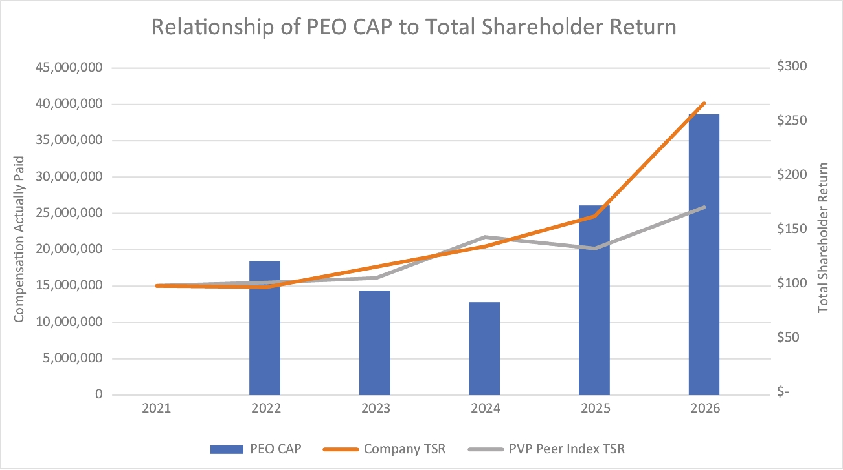

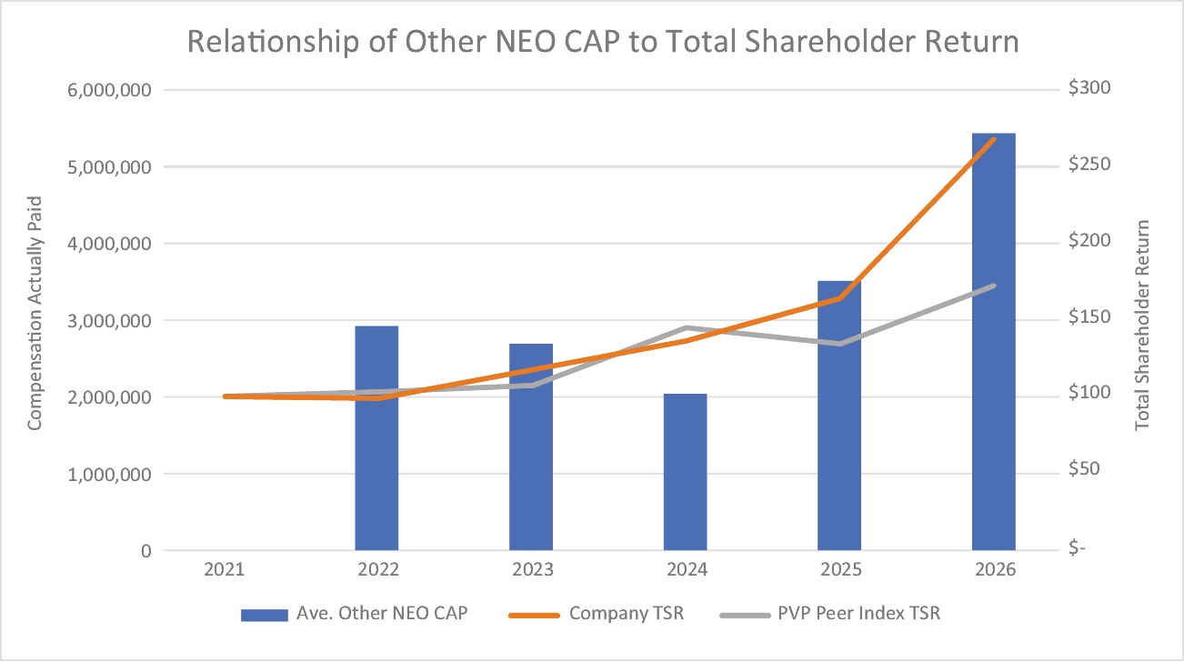

 |  |  |  |  |  | 2026 Proxy Statement |  |  | 45

TABLE OF CONTENTS
The following charts show the relationships between the Company’s net income, our PEO’s CAP, and our other NEOs’ CAP.
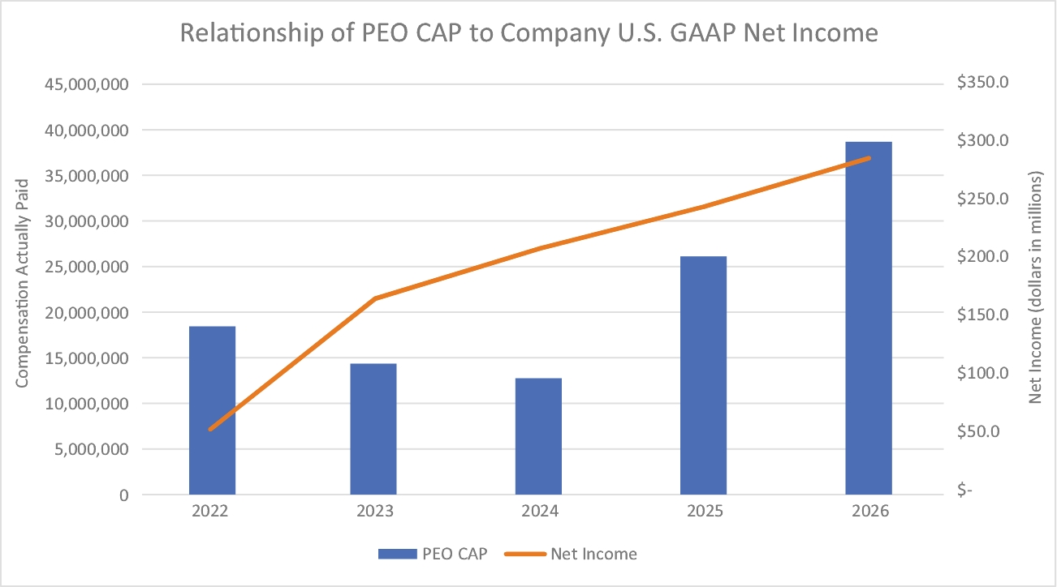

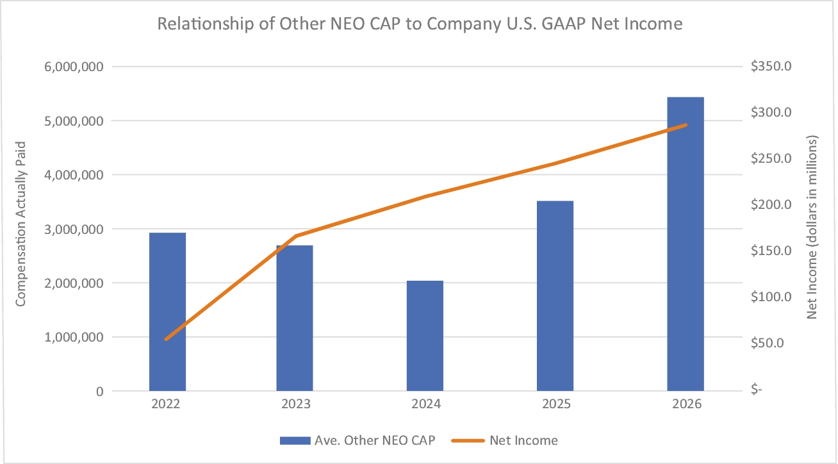

46 |  |  |  |  |  | 2026 Proxy Statement

TABLE OF CONTENTS
The following charts show the relationships between the Company’s adjusted EBITDA, our PEO’s CAP, and our other NEOs’ CAP.
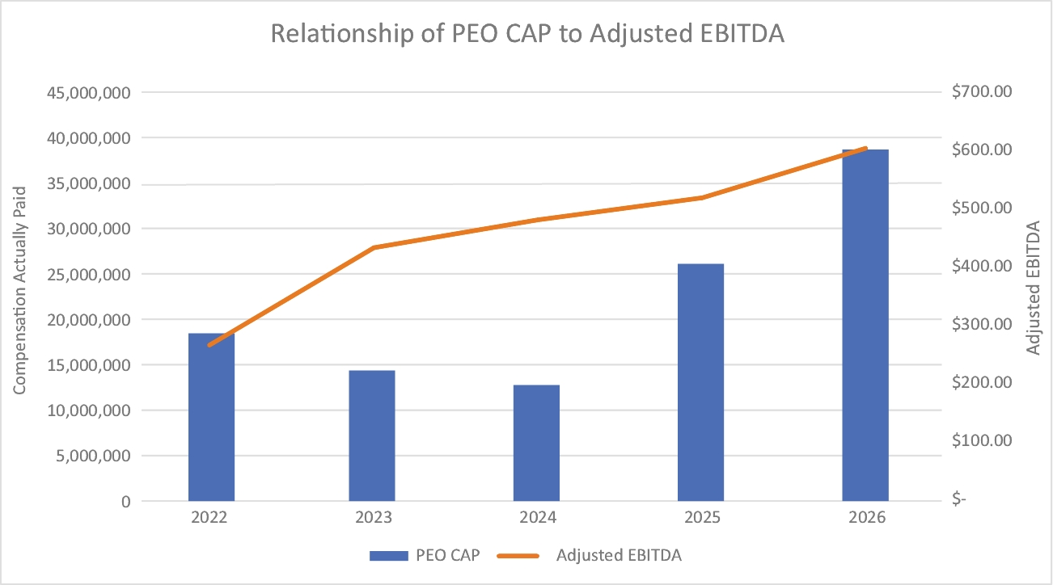

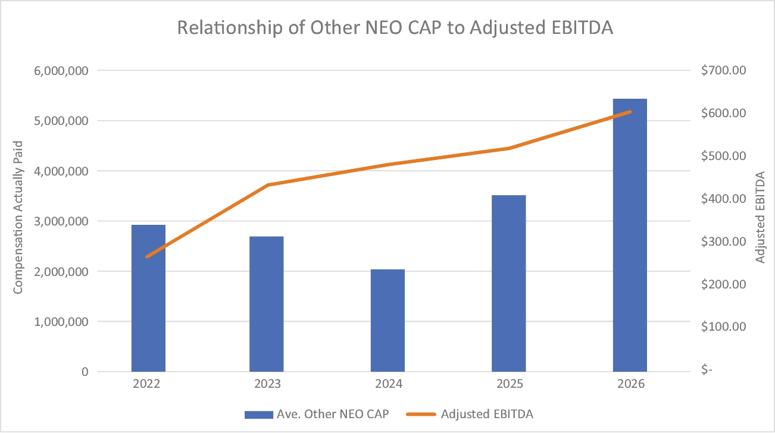

 |  |  |  |  |  | 2026 Proxy Statement |  |  | 47

TABLE OF CONTENTS
Important Financial Performance Measures
The following table provides what we believe are the most important financial performance measures we used to link executive pay for our PEO and Other NEOs for 2026 to our performance:
 | Performance Measure |  |  | Type of Performance Measure
 | Adjusted EBITDA |  |  | Financial
 | Return on Invested Capital |  |  | Financial
 | Free Cash Flow |  |  | Liquidity

Equity Incentive Plans
Generally
Initially, 1,500,000 shares of our common stock were authorized for issuance under each of the long-term equity incentive plans, subject to adjustment in the event of a reorganization, stock split, merger or similar change in our corporate structure or the outstanding shares of common stock. Not more than 50% of the total authorized shares under any of the plans may be awarded as restricted stock. As of July 7, 2026, the number of unrestricted shares, restricted shares, and stock options that had been awarded and the number of shares available for future awards under each plan were as follows:
The Company maintains two long-term equity incentive plans: the 2017 Long-Term Incentive Plan (approved by our stockholders at the 2017 stockholder meeting); and the 2021 Long-Term Incentive Plan (approved by our stockholders at the 2021 stockholder meeting). These plans provide for awards of stock options, stock appreciation rights, restricted stock and performance awards. Our
directors, officers and other employees and persons who engage in services for us are eligible for awards under the plans. The purpose of the plans is to provide these individuals with incentives to maximize stockholder value and otherwise contribute to our success and to enable us to attract, retain and reward the best available persons for positions of responsibility.
 |  |  |  | Unrestricted  Shares Awarded |  |  | Restricted Shares  Awarded |  |  | Stock Options Awarded |  |  | Shares Still  Available
 | 2017 Long-Term Incentive Plan |  |  | 52,348 |  |  | 616,241 |  |  | 845,965 |  |  | 37,794
 | 2021 Long-Term Incentive Plan |  |  | - |  |  | - |  |  | - |  |  | 1,500,000
 | Total |  |  | 52,348 |  |  | 616,241 |  |  | 845,965 |  |  | 1,537,794
Administration of the Plans
Our Compensation Committee administers the long-term equity incentive plans. The Board also has the authority to administer the plans and to take all actions that the Compensation Committee is otherwise authorized to take under the plans. The terms and conditions of each award made under each plan, including vesting requirements, are set forth, consistent with the plan, in a written agreement with the award recipient.
Stock Options. The Compensation Committee may award incentive stock options and non-qualified stock options. The Compensation Committee also has the authority to award options that will become fully vested and exercisable automatically upon a change in control. The Compensation Committee may not, however, approve an award to any one person (other than Dr. Hartnett) in any calendar year of options to purchase common stock equal to more than 10% of the total number of shares authorized under the plan, and it may not award incentive stock options first exercisable in any calendar
year whose underlying shares have a fair market value greater than $100,000 determined at the time of award. The Compensation Committee will determine the exercise price and term of any option in its discretion, provided that the exercise price may not be less than 100% of the fair market value of a share of common stock on the date of award. In the case of incentive stock options, the option must be exercised within 10 years of the date of award. The exercise price of an incentive stock option awarded to a person who owns stock constituting more than 10% of our voting power may not be less than 110% of fair market value on the award date and the option must be exercised within five years of the date of award. The Compensation Committee has never awarded any incentive stock options under any of the plans.
Restricted Stock. The Compensation Committee may award restricted stock, subject to the conditions and restrictions, and
48 |  |  |  |  |  | 2026 Proxy Statement

TABLE OF CONTENTS
Equity Compensation Plan Information
for the duration that it determines in its discretion. In addition to not being transferable, the restricted stock previously awarded under the plans does not have the right to vote or receive dividends until it vests.
Stock Appreciation Rights. The Compensation Committee may award stock appreciation rights (SARs), subject to the terms and conditions contained in the relevant plan. The exercise price of an SAR must equal the fair market value of a share of our common stock on the date the SAR is awarded. Upon exercise of an SAR, the recipient will receive an amount in shares of our common stock equal to the difference between the fair market value of a share of common stock on the date of exercise and the exercise price of the SAR, multiplied by the number of shares as to which the SAR is exercised.
Performance Awards. The Compensation Committee may make performance awards contingent upon achievement of set goals and objectives regarding specified performance criteria, over a specified performance cycle. Awards may include specific dollar-value target awards, performance units the value of which is established at the time of award, and/or performance shares the value of which is equal to the fair market value of a share of common stock on the date of award. The value of a performance award may be fixed or fluctuate on the basis of specified performance criteria. A performance award may be paid out in cash and/or shares of common stock or other securities.
Amendment, Termination and Expiration of the Plans. The Board may amend or terminate any of the long-term equity incentive plans in its discretion, except that no amendment will become effective without prior approval of our stockholders if such approval is required by the NYSE listing requirements. If not
previously terminated by the Board, each plan will expire on the tenth anniversary of its adoption.
Except in the case of the CEO and COO, the Company does not have an established quantitative formula to determine the number of stock options and/or shares of stock awarded to each executive officer. See “Compensation Program Components and Pay Outcomes for Fiscal 2026—Long-Term Equity Incentive Awards” above.
Disclosure of Policies and Practices Related to the Grant of Certain Equity Awards Close in Time to the Release of Material Nonpublic Information. The Compensation Committee makes executive officer equity awards once each fiscal year during the first to third week after the filing of the Company’s annual report on Form 10-K for the prior fiscal year. On occasion the Compensation Committee may determine that it is appropriate to make additional awards to an executive officer at another time of the year, but the Committee only does so at times that the Committee members would be permitted to trade RBC stock under our Insider Trading Policy (i.e., only when Committee members are not in possession of material nonpublic information regarding the Company and only during trading windows). For example, the Compensation Committee awarded shares of restricted stock and stock options to CFO Robert Sullivan on November 5, 2024, the first day of the trading window following the release of our financial results for the second quarter of fiscal 2025. As a result of this policy, no awards were made to executive officers in fiscal 2026 during the period starting four business days before, and ending one business day after, the filing or furnishing of any of our Exchange Act periodic reports.
The following table provides information about the Company’s common stock that may be issued upon the exercise of options, warrants and rights under all of our existing equity compensation plans as of July 7, 2026, consisting of the 2017 Long-Term Incentive Plan and 2021 Long-Term Incentive Plan.
 | Plan Category |  |  | Number of securities to  be issued upon exercise  of outstanding options,  warrants and rights |  |  | Weighted-average  exercise price of  outstanding options,  warrants and rights |  |  | Number of securities  remaining available  for future issuance  under equity  compensation plans
 | Equity compensation plans  approved by stockholders(1) |  |  | 204,779 |  |  | $287.64 |  |  | 1,537,794
(1) | The Company does not have equity compensation plans that have not been approved by our stockholders.
 |  |  |  |  |  | 2026 Proxy Statement |  |  | 49

TABLE OF CONTENTS

CEO Pay Ratio
As of March 28, 2026, the Company had 5,816 employees located in 11 countries around the world, of whom 4,187 were located in the United States. For fiscal 2026, the estimated median of the annual total compensation of all those employees worldwide (excluding our CEO) was $70,772 and the estimated median of the annual total compensation of all those employees located in the United States (excluding our CEO) was $77,126. The total compensation of our CEO, Dr. Hartnett, in fiscal 2026 was $20,912,354 (including a stock award made in fiscal 2027 based on performance in fiscal 2026, stock awards made in fiscal 2027 based on performance in the three years ending with fiscal 2026, and stock awards to be made in fiscal 2029 based on performance in the three years ending with fiscal 2028 (see the Summary Compensation table above)), which was 295 times the compensation of the median employee worldwide, and 271 times the compensation of the median employee in the United States. We used a sampling technique to identify the median employee, selecting 1,330 of our international employees and 4,158 of our
United States employees, for a total sample of 5,458 worldwide employees. We then identified the individual in each of the two samples who received the median compensation (using for this purpose salary (including base wages), bonus, equity compensation and overtime actually paid during fiscal 2026). We then determined the annual total compensation of those two employees as shown above on substantially the same basis as used for the CEO in the Summary Compensation table. The CEO pay ratio reported above is a reasonable estimate calculated in a manner consistent with SEC rules based on the methodologies and assumptions described above. SEC rules for identifying the median employee and determining the CEO pay ratio permit companies to use a wide range of methodologies, estimates and assumptions. As a result, the CEO pay ratios reported by other companies, which may have employed other permitted methodologies or assumptions and which may have a significantly different work force structure from ours, are likely not comparable to our CEO pay ratio.
Principal Accountant Fees and Services
The following table presents fees for professional services rendered by Ernst & Young LLP for fiscal 2026 and fiscal 2025.
 |  |  |  | Fiscal Year Ended
 |  |  |  | March 28, 2026 |  |  | March 29, 2025
 | Audit Fees |  |  | $2,956,000 |  |  | $2,058,800
 | Audit-Related Fees |  |  | - |  |  | -
 | Tax Fees |  |  | - |  |  | -
 | Other Fees |  |  | 3,600 |  |  | 3,600
 | Total Fees |  |  | $2,959,600 |  |  | $2,062,400
Audit Fees. Consists of fees billed for professional services rendered for the audit of our consolidated financial statements and review of the interim consolidated financial statements included in quarterly reports and services that are normally provided by Ernst & Young LLP in connection with statutory and regulatory filings or engagements.
Audit-Related Fees. Consists of fees billed for assurance and related services that are reasonably related to the performance of the audit or review of our consolidated financial statements and are not reported under “Audit Fees.”
Tax Fees. Consists principally of fees for services provided in connection with worldwide tax planning and compliance services, expatriate tax services, and assistance with tax audits and appeals.
Other. Consists of subscription fees for an accounting research service.
Pursuant to the Audit Committee’s charter, the Committee must approve all audit engagement fees and other significant compensation to be paid to the independent registered public accounting firm and the terms of such engagement. The Audit Committee’s charter provides that individual engagements must be separately approved. Additionally, the Audit Committee must pre-approve any non-audit services to be provided to the Company by the independent registered public accounting firm. The Audit Committee policy also requires specific approval by the Audit Committee if total fees for audit-related and tax services would exceed total fees for audit services in any fiscal year. The Audit Committee’s charter authorizes the Committee to delegate to one or more of its members pre-approval authority with respect to permitted services.
All audit services performed by Ernst & Young in fiscal 2026 and fiscal 2025 were pre-approved by the Audit Committee, which concluded that the provision of such services by Ernst & Young was compatible with the maintenance of that firm’s independence in the conduct of its auditing functions.
50 |  |  |  |  |  | 2026 Proxy Statement

TABLE OF CONTENTS

Audit Committee Report
The Audit Committee has reviewed and discussed the audited financial statements with management, which has represented that the financial statements were prepared in accordance with accounting principles generally accepted in the United States. The Audit Committee discussed with management the quality and acceptability of the accounting principles employed, including all critical accounting policies used in the preparation of the financial statements and related notes, the reasonableness of judgments made and the clarity of the disclosures included in the statements.
The Audit Committee also reviewed the consolidated financial statements of the Company for fiscal 2026 with Ernst & Young LLP, the Company’s independent registered public accounting firm, who are responsible for expressing an opinion on the conformity of those audited financial statements with accounting principles generally accepted in the United States. The Audit Committee has discussed with Ernst & Young the matters required to be discussed by applicable standards of the Public Company Accounting Oversight Board (PCAOB) and the U.S. Securities and Exchange Commission (SEC) including matters related to the planning and results of the audit of the Company’s consolidated financial statements.
The Audit Committee also reviewed management’s report on its assessment of the effectiveness of the Company’s internal control over financial reporting and the independent registered
public accounting firm’s report on management’s assessment of and the effectiveness of the Company’s internal control over financial reporting.
The Audit Committee has received the written disclosures and the letter from Ernst & Young required by the PCAOB relating to Ernst & Young’s communications with the Audit Committee concerning independence, and has discussed with Ernst & Young its independence and has considered whether the provision of non-audit services by Ernst & Young to the Company is compatible with maintaining Ernst & Young’s independence.
In reliance on the reviews and discussions referred to above, the Audit Committee recommended to the Board that the audited financial statements be included in the Company’s Annual Report on Form 10-K for the year ended March 28, 2026.
The Audit Committee has selected Ernst & Young as the Company’s independent registered public accounting firm for fiscal 2027.
Respectfully submitted,
The Audit Committee of the Board of RBC Bearings Incorporated
Edward D. Stewart (Chair)
Richard R. Crowell
Frederick J. Elmy
Stockholder Proposals and Director Nominations
Stockholder Proposals
Stockholders interested in submitting a proposal for inclusion in the proxy statement relating to the Company’s next annual meeting of stockholders in 2027 may do so by following the procedures set forth in Rule 14a-8 under the Exchange Act. In general, to be eligible for inclusion in the Company’s proxy statement, stockholder proposals must be received by the Company at its principal executive offices (located at 102 Willenbrock Road, Oxford, CT 06478) no later than March 26, 2027.
Under the Company’s by-laws, proposals of stockholders not intended for inclusion in the proxy statement, but intended to be raised at the 2027 annual meeting, must be delivered to or mailed and received at c/o Secretary, RBC Bearings Incorporated, 102 Willenbrock Road, Oxford, CT 06478 no earlier than June 5,
2027 (i.e., 90 days prior to the anniversary of this year’s annual meeting) and no later than July 5, 2027 (i.e., 60 days prior to the anniversary of this year’s annual meeting); provided, however, that in the event that less than 70 days’ notice or prior public announcement of the date of the 2027 annual meeting is given or made to stockholders, notice by the stockholder to be timely must be received not later than the close of business on the tenth day following the date on which such notice of the date of the 2027 annual meeting is mailed or publicly announced. A stockholder’s notice must also comply with the timing, disclosure, procedural and other requirements set forth in the Company’s by-laws, a copy of which is available upon request from RBC’s Secretary at the above address.
 |  |  |  |  |  | 2026 Proxy Statement |  |  | 51

TABLE OF CONTENTS
Stockholder Director Nominations
A stockholder may suggest director candidates for consideration by the Board’s Nominating and Governance Committee. Any such suggestion should include the nominee’s name and qualifications for Board membership and should be directed to the Secretary, RBC Bearings Incorporated, 102 Willenbrock Road, Oxford, CT 06478. The Board evaluates director nominees recommended by stockholders in the same manner in which it evaluates other director nominees. The Board has established, through the Nominating and Governance Committee, selection criteria that identify desirable skills and experience for prospective Board members, including consideration of the potential candidate’s qualification as independent, as well as consideration of skills, expertise and experience in the context of the Board and other criteria determined by the Nominating and Governance Committee from time to time.
The Company’s by-laws permit stockholders to nominate directors for election at an annual stockholders meeting. To nominate a director, a stockholder must deliver timely notice of such stockholder’s intent to make such nomination in writing to the Secretary. To be timely for the 2027 annual meeting, a stockholder’s notice must be delivered to or mailed and received at c/o Secretary, RBC Bearings Incorporated, 102 Willenbrock Road, Oxford, CT 06478, no earlier than the close of business on June 5, 2027 (i.e., 90 days prior to the anniversary of this year’s
annual meeting) and no later than July 5, 2027 (i.e., 60 days prior to the anniversary of this year’s annual meeting). In the event that the date of the 2027 annual meeting is more than 30 days from the anniversary of this year’s annual meeting, notice by the stockholder to be timely must be received not later than the close of business on the tenth day following the day on which the date of the 2027 meeting is mailed or publicly announced. A stockholder’s notice must also comply with the timing, disclosure, procedural and other requirements set forth in the Company’s by-laws.
In addition to satisfying the requirements under the Company’s by-laws, to comply with the universal proxy rules under the Exchange Act, any stockholder who intends to solicit proxies in support of director nominees other than the Board’s nominees for the 2027 annual meeting must provide a written notice that sets forth the information required by Rule 14a-19 under the Exchange Act no later than July 5, 2027 (i.e., 60 days prior to the anniversary of this year’s annual meeting). However, if the date of the 2027 annual meeting is more than 30 days from the anniversary of this year’s annual meeting, then such notice must be delivered by the later of (i) the tenth day following the public announcement of the date of the 2027 annual meeting and (ii) the date that is 60 days prior to the date of the 2027 annual meeting.
Additional Information About the Annual Meeting
Why did I receive these materials?
The Company is furnishing proxy materials to stockholders via the internet. If you received a Notice of Internet Availability of Proxy Materials (the “Notice”) by mail, you will not receive a printed copy of the proxy materials unless you specifically request one. The Notice instructs you on how to access and review all of the important information contained in this proxy statement and our annual report as well as how to submit your proxy over the
internet. If you received the Notice and would still like to receive a printed copy of our proxy materials, you should follow the instructions for requesting these materials included in the Notice. We plan to mail the Notice to stockholders on or about July 24, 2026. We will mail a printed copy of this proxy statement and form of proxy to certain stockholders and we expect that mailing to begin on or about July 24, 2026.
How may I obtain RBC’s 10-K and other financial information?
You are receiving a proxy statement because you owned shares of our common stock on July 7, 2026 (the “Record Date”), which entitles you to vote at the meeting. By use of a proxy, you can vote whether or not you attend the meeting. This proxy statement
describes the matters on which you may vote and provides information on those matters so that you can make an informed decision.
Stockholders may find the 2026 Form 10-K and our other filings with the SEC, as well as other information regarding the Company, on the Investor Relations page of our website at www.investor.rbcbearings.com. If you received our proxy statement in the mail, a copy of our 2026 Annual Report on
Form 10-K was enclosed with the proxy statement. Stockholders may request a free copy of the 2026 Form 10-K from the Secretary, RBC Bearings Incorporated, 102 Willenbrock Road, Oxford, CT 06478 (203-267-7001).
52 |  |  |  |  |  | 2026 Proxy Statement

TABLE OF CONTENTS
Who is entitled to vote at the meeting?
What constitutes a quorum for the meeting?
Only stockholders of record at the close of business on the Record Date are entitled to receive notice of and to vote at the annual meeting. If you were a stockholder of record on the
Record Date, you will be entitled to vote all of the shares that you held on that date at the meeting, or any postponements or adjournments of the meeting.
What vote is required to approve each item?
The presence at the meeting, in person or by proxy, of the holders of a majority of the shares of our common stock outstanding on the Record Date and eligible to vote will constitute a quorum permitting the conduct of business at the meeting. As of the Record Date, there were 31,594,011 shares of common stock
outstanding and eligible to vote. Proxies received by the Company but marked as abstentions and broker non-votes will be included in the calculation of the number of shares considered to be present at the meeting for purposes of determining if we have a quorum.
Will stockholders be asked to vote on any other matters?
Election of Directors (Proposal 1): Directors are elected by a majority of the votes of the shares present in person or represented by proxy at the meeting and entitled to vote. Each share of our common stock is entitled to one vote for each of the director nominees (i.e., stockholders do not have cumulative voting rights).
Approval of Independent Registered Public Accounting Firm (Proposal 2): The ratification of the appointment of Ernst & Young LLP to serve as the Company’s independent registered public accounting firm for fiscal 2027 requires the affirmative vote of a majority of the votes of the shares present in person or represented by proxy at the meeting and entitled to vote.
Approval of the Say-on-Pay Proposal (Proposal 3): The approval of the resolution regarding the stockholder advisory vote on named executive officer compensation requires the affirmative vote of a majority of the shares represented at the meeting.
A properly executed proxy marked “ABSTAIN” with respect to a particular proposal will not be voted on that proposal (although it will be counted for purposes of determining whether there is a quorum at the meeting). Therefore, an abstention with respect to any of Proposal 1, Proposal 2 or Proposal 3 will have the same effect as an “AGAINST” vote on that proposal.
What are the Board’s recommendations?
To the knowledge of the Company, stockholders will vote only on the matters described in this proxy statement. However, if any other matters properly come before the meeting, the persons
acting as proxy holders will vote on those matters in the manner they consider appropriate.
How do I vote?
The Board’s recommendations are set forth in this proxy statement together with the description of each proposal to be voted upon. In summary, the Board recommends a vote FOR
each of Proposals 1, 2 and 3. Unless you give other instructions when you vote, the persons acting as proxy holders will vote in accordance with the recommendations of the Board.
If you are a holder of record (that is, your shares are registered in your own name with our transfer agent), you can vote either in person at the annual meeting or by proxy without attending the annual meeting. We urge you to vote by proxy even if you plan to attend the annual meeting so that we will know as soon as possible that enough votes will be present for us to hold the meeting. If you attend the meeting in person, you may vote at the meeting and your proxy will not be counted. You can vote by proxy over the Internet (at www.ProxyVote.com), by telephone (1-800-579-1639) or, if you received paper copies of our proxy materials in the mail, by completing, dating and signing a proxy card and returning it in the enclosed postage-paid envelope.
If you hold your shares in “street name,” you must either direct the bank, broker or other record holder of your shares as to how to
vote your shares, or obtain a proxy from the bank, broker or other record holder to vote at the meeting. Please refer to the materials provided by your bank, broker or other record holder for specific instructions on methods of voting available to you.
If you properly submit a proxy, your shares will be voted in accordance with your instructions. If you submit a proxy but do not specify how you want to vote your shares, the proxy holders will vote them in accordance with the recommendations of the Board. If you submit a proxy but wish to revoke it, you may do so by submitting a proxy containing a later date or by attending the meeting and voting in person.
 |  |  |  |  |  | 2026 Proxy Statement |  |  | 53

TABLE OF CONTENTS
What if I Hold My Shares in Street Name?
What should I do if I receive more than one set of voting materials?
If you hold your shares in “street name” through a broker, bank or other nominee rather than directly in your own name, then your broker, bank or other nominee is considered the stockholder of record, and you are considered the beneficial owner of your shares. The Company has supplied copies of its proxy materials for the 2026 annual meeting of stockholders to the broker, bank or other nominee holding your shares of record, and they have the responsibility to send these proxy materials to you. As the beneficial owner, you have the right to direct your broker, bank or other nominee on how to vote your shares at the annual meeting.
If your broker, bank or other nominee does not receive voting instructions from you, your shares may constitute “broker non-
votes.” Generally, broker non-votes occur with respect to a proposal when a broker is not permitted to vote on that proposal without instructions from the beneficial owner and instructions are not given. Shares represented by broker non-votes will be counted in determining whether there is a quorum at the meeting, but will not be considered voted with respect to those proposals to which the broker non-votes relate. Without instruction from you, your broker may not vote with respect to any of the proposals at the 2026 annual meeting except for the ratification of the appointment of the Company’s independent registered public accounting firm (Proposal 2).
How and when may I propose actions for consideration at next year’s annual meeting of stockholders or recommend or nominate individuals to serve as directors?
You may receive more than one Notice or set of proxy materials. For example, if you hold your shares in more than one brokerage account, you may receive a separate voting instruction card for each brokerage account in which you hold shares. If you are a
stockholder of record and your shares are registered in more than one name, you will receive more than one Notice or proxy card. Please vote with respect to each Notice or set of proxy materials that you receive.
See “Stockholder Proposals and Director Nominations” above.
Additional Information Regarding the Solicitation
The Company will bear the cost of the annual meeting and the cost of this proxy solicitation. In addition to solicitation by mail, directors, officers and employees of the Company may solicit proxies by telephone or otherwise, with no specific additional compensation to be paid for such services. The Company has not retained a proxy solicitor. The Company will reimburse, upon request, all brokers and other persons holding shares of common stock for the benefit of others for their reasonable expenses in forwarding the Company’s proxy materials and any accompanying materials to the beneficial owners and in obtaining authorization from beneficial owners to give proxies.
The Board knows of no matter to be brought before the annual meeting other than the matters identified in this proxy statement. If, however, any other matter properly comes before the annual meeting, the individuals named in the proxy solicited by the Board intend to vote on it on behalf of the stockholders they represent in the manner the proxy holders consider appropriate.
By order of the Board of Directors,
John J. Feeney
Vice President, General Counsel and Secretary
July 24, 2026
54 |  |  |  |  |  | 2026 Proxy Statement

TABLE OF CONTENTS

APPENDIX A:
Directions to RBC

RBC Bearings Incorporated
Building B, 102 Willenbrock Road
One Tribology Center
Oxford, CT 06478.
Connecticut I-84 East or West to exit 16
Head south on CT-188 S/Strongtown Road toward CT-67 N/Seymour Road
Turn left onto CT-188 S/CT-67 S/Seymour Road
Continue straight to follow CT-67 S/Seymour Road
Take the 1st left onto Hawley Road
Take the 2nd right onto Willenbrock Road
Destination will be the second building on the left
 |  |  |  |  |  | 2026 Proxy Statement |  |  | 55

TABLE OF CONTENTS

APPENDIX B:
Reconciliation of Reported Net Income to Adjusted EBITDA
(dollars in millions)
 |  |  |  | March 28,  2026 |  |  | March 29,  2025 |  |  | March 30,  2024 |  |  | April 1,  2023 |  |  | April 2,  2022
 | Reported net income |  |  | $287.6 |  |  | $246.2 |  |  | $209.9 |  |  | $166.7 |  |  | $54.7
 | Interest expense, net |  |  | 49.8 |  |  | 59.8 |  |  | 78.7 |  |  | 76.7 |  |  | 41.5
 | Provision for income taxes |  |  | 81.7 |  |  | 65.7 |  |  | 51.9 |  |  | 43.0 |  |  | 24.0
 | Stock-based compensation expense |  |  | 34.5 |  |  | 28.4 |  |  | 17.4 |  |  | 14.0 |  |  | 32.9
 | Depreciation and amortization |  |  | 128.8 |  |  | 120.0 |  |  | 119.3 |  |  | 115.4 |  |  | 65.5
 | Other non-operating expense |  |  | 1.9 |  |  | 2.2 |  |  | 2.1 |  |  | 2.3 |  |  | 0.8
 | Inventory step-up |  |  | - |  |  | - |  |  | - |  |  | - |  |  | 13.8
 | Transaction and related costs |  |  | 14.8 |  |  | - |  |  | 0.3 |  |  | 0.1 |  |  | 22.7
 | Transition services |  |  | - |  |  | - |  |  | - |  |  | 8.8 |  |  | 8.0
 | Restructuring and consolidation |  |  | 6.2 |  |  | 1.5 |  |  | 3.0 |  |  | 2.6 |  |  | 2.6
 | Legal settlement |  |  | - |  |  | (4.0) |  |  | - |  |  | - |  |  | -
 | Pension settlement |  |  | - |  |  | - |  |  | (0.5) |  |  | 4.3 |  |  | -
 | Adjusted EBITDA |  |  | $605.3 |  |  | $519.8 |  |  | $482.1 |  |  | $433.9 |  |  | $266.5
56 |  |  |  |  |  | 2026 Proxy Statement

TABLE OF CONTENTS
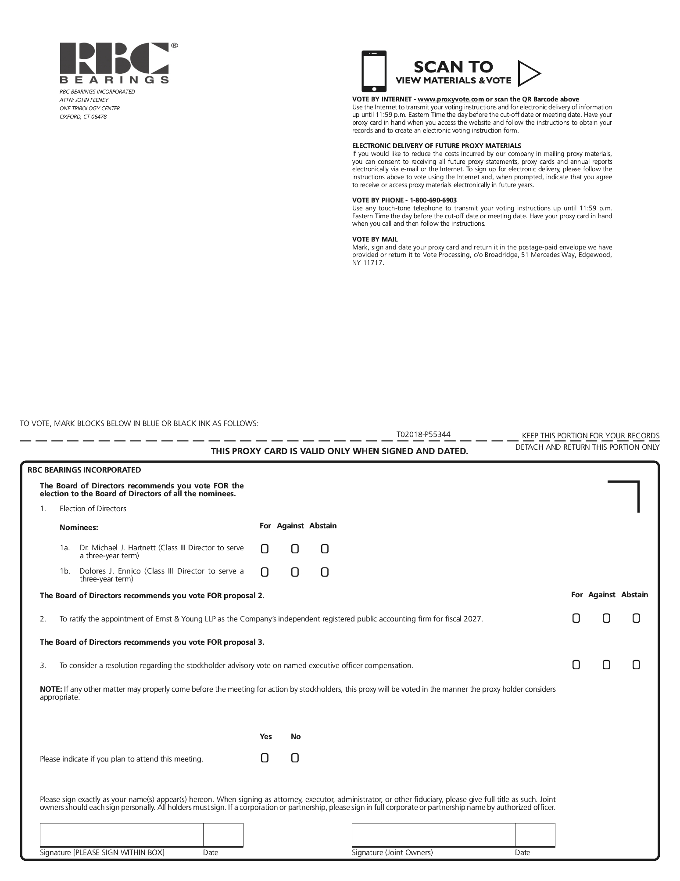

TABLE OF CONTENTS


